FROM PROMPT TO TIMETABLE: INTEGRATING NATURAL LANGUAGE REASONING WITH DIFFERENT HYPER-HEURISTIC ALGORITHMS.

BY

ADEKOMI, ANJOLAOLUWA JOY
(22CH031976)

A PROJECT PROPOSAL SUBMITTED TO THE DEPARTMENT OF COMPUTER AND INFORMATION SCIENCES, COLLEGE OF SCIENCE AND TECHNOLOGY, COVENANT UNIVERSITY OTA, OGUN STATE.

IN PARTIAL FULFILLMENT OF THE REQUIREMENTS FOR THE AWARD OF THE BACHELOR OF SCIENCE (HONOURS) DEGREE IN MANAGEMENT INFORMATION SYSTEMS

JUNE, 2026.

CERTIFICATION
I hereby certify that this project was carried out by Adekomi, Anjolaoluwa Joy, in the Department of Computer and Information Sciences, College of Science and Technology, Covenant University, Ogun State, Nigeria, under my supervision.

Mr. Henry Ogbu
Supervisor | Signature and Date
Prof. Aderonke A. Oni
Head of Department | Signature and Date

DEDICATION

This report is dedicated to Almighty God for His guidance and grace throughout my internship journey. I also dedicate it to my parents, family, friends, and everyone who continually inspires me to strive for excellence.

ACKNOWLEDGEMENTS
My most profound gratitude goes to Almighty God, who has kept me and sustained me right from the very start of my degree up until this point. To Him be all the glory. I am extremely grateful to my parents, Mr. and Mrs. Adelowo Adekomi, for their sacrifices, contributions, and prayers towards the completion of this degree. My sincere gratitude also goes to my hardworking supervisor, Mr. Henry Ogbu, who always provided his support. Thank you for your excellent supervision and guidance, sir.

TABLE OF CONTENTS

CERTIFICATION 2
DEDICATION 3
ACKNOWLEDGEMENTS 4
TABLE OF CONTENTS 5
CHAPTER ONE 16
INTRODUCTION 16
1.1 Background Information 16
1.2 Statement of the Problem 17
1.3 Aim and Objectives of the Study 18
1.4 Methodology 18
1.5 Significance of the Study 19
1.5.1 Practical Significance 19
1.5.2 Academic and Research Significance 19
1.6 Project Outline 19
CHAPTER TWO 20
LITERATURE REVIEW 20
2.1 Preamble 20
2.2 Review of University Course Timetabling Problems 20
2.3 Review of Heuristic and Meta-heuristic Approaches 21
2.4 Review of Hyper-heuristic Approaches 22
2.5 Review of Natural Language Processing in Scheduling and Optimization 22
2.6.1 Hyper-heuristics 23
2.6.2 Optimization and NP-Hard Problems 23
2.6.3 Web-based Timetabling Systems 23
2.6.4 Hard constraints 23
2. 6.5 Soft constraints 24
2.9 Existing Works 26
2.10 Summary of Literature Review 26
CHAPTER THREE 28
RESEARCH METHODOLOGY 28
3.1 Preamble 28
3.2 Research Design 28
3.3 Population, Data Source, and Data Limitations 29
3.3.1 Data Collection Process and Limitations 29
3.3.2 Dataset Characteristics 30
3.3.3 Venue Classification 30
3.3.4 Data Preprocessing Pipeline 31
3.4 System Analysis 32
3.4.1 Analysis of the Existing System 32
3.4.2 Analysis of the Proposed System 33
3.5 Proposed System Description 34
3.5.1 System Overview 34
3.5.2 Key System Features 34
3.6 System Architecture 35
3.7 Input Design 36
3.7.1 Academic Resource Dataset (CSV) 36
3.7.2 Natural Language Constraints 36
3.8 Output Design 36
3.9 Database Design 37
3.9.1 Database Technology 37
3.9.2 Database Schema 37
3.10 Constraint Definition 38
3.10.1 Hard Constraints 38
3.10.2 Soft Constraints 39
3.10.3 Special Constraints 39
3.11 Fitness Function Design 40
3.11.1 Mathematical Formulation 40
3.11.2 Violation Detection Logic 40
3.11.3 Weight Justification 41
3.13 Algorithm Design 42
3.13.1 Overview of the Hyper-Heuristic Approach 42
3.13.2 Problem Representation 43
3.13.3 Genetic Algorithm Methodology 43
3.13.4 Simulated Annealing Methodology 45
3.13.5 Tabu Search Methodology 47
3.13.6 Mutation Operator Design 49
3.13.7 Hyper-Heuristic Selection Strategy 50
3.14 NLP Constraint Parsing Module 50
3.14.1 Architecture 50
3.14.2 Parsing Pipeline 50
3.14.3 Hard and Soft Constraint Merging 50
3.14.4 Supported Constraint Patterns 51
3.15 UML Diagrams 51
3.15.1 Use Case Diagram 51
3.15.2 Activity Diagram — Timetable Generation Process 52
3.15.3 Sequence Diagram - Optimisation Flow 53
3.15.4 Class Diagram 53
3.16.1 Software Requirements 54
3.16.2 Hardware Requirements 54
3.17 Implementation Procedures 54
3.17.1 Development Methodology 54
3.17.2 Technology Stack 55
3.17.3 Directory Structure 55
3.18 Evaluation Strategy 56
3.18.1 Evaluation Metrics 56
3.18.2 Experimental Design 56
CHAPTER FOUR 58
RESULTS AND DISCUSSION 58
4.2.1 Welcome and Login Interface 58
4.2.2 Four-Step Administrator Workflow 59
4.2.3 Timetable Visualisation 59
4.3.1 Unit Testing 59
4.3.2 Integration Testing 60
4.3.3 NLP Constraint Parsing Test Results 60
4.4.1 Dataset Configuration 60
4.4.2 Algorithm Parameters 61
4.5.1 Initial Timetable Baseline Evaluation 61
4.5.2 Genetic Algorithm Results 62
4.5.3 Simulated Annealing Results 62
4.5.4 Tabu Search Results 63
4.5.5 Comprehensive Comparative Analysis 63
4.5.6 Fitness Score Reduction Summary 63
4.5.7 Convergence Analysis 64
4.5.8 Clash Elimination Analysis 64
4.5.9 Execution Time Analysis 64
4.8.1 Effectiveness of the Hyper-Heuristic Approach 66
4.8.2 Why the Genetic Algorithm Performed Best 66
4.8.3 Why Simulated Annealing Underperformed Relative to GA 67
4.8.4 Tabu Search Performance Assessment 67
4.8.5 Impact of NLP Integration on Usability 67
4.8.6 Capacity Violations as the Most Persistent Challenge 67
4.8.7 Scalability Considerations 68
4.8.8 Comparison with Related Work 68
4.8.9 Achievement of Research Objectives 68
CHAPTER FIVE 70
SUMMARY, CONCLUSION, AND RECOMMENDATIONS 70
5.1 Introduction 70
5.2 Summary 70
5.2.1 Problem Statement 70
5.2.2 Research Objectives Revisited 70
5.2.3 Methodology Summary 70
5.2.4 Key Results Summary 71
5.3 Achievement of Objectives 71
5.3.1 Objective 1: Intelligent Timetable Generation System 71
5.3.2 Objective 2: NLP Constraint Specification 71
5.3.3 Objective 3: Multi-Algorithm Implementation 71
5.3.4 Objective 4: Comparative Evaluation 72
5.3.5 Objective 5: Web-Based Interface 72
5.4 Findings 72
5.5 Contributions 73
5.5.1 Theoretical Contributions 73
5.5.2 Practical Contributions 74
5.6 Limitation 74
5.7 Conclusion 75
5.8 Recommendations 76
5.8.1 For Institutional Adoption 76
5.8.2 For Future Development 76
5.9 Future Work 77
REFERENCES 79

LIST OF FIGURES
FIGURE | TITLE OF FIGURE | PAGES
2.1 Broad Categorization of Hyper-Heuristics for Timetabling 22
3.1 Data Preprocessing Pipeline Flowchart 32
3.2 High-Level System Architecture Diagram 35
3.3 Entity-Relationship Diagram (ERD) 38
3.4 Room Selection Strategy Flowchart 42
3.5 Genetic Algorithm Flowchart 45
3.6 Simulated Annealing Flowchart 46
3.7 Tabu Search Flowchart 48
3.8 Mutation Operator Flowchart 49
3.9 NLP Constraint Parsing Pipeline 50
3.10 Use Case Diagram 51
3.11 Activity Diagram - Timetable Generation Workflow 52
3.12 Sequence Diagram- System Optimization Flow 53
3.13 Class Diagram 53
3.14 Technology Stack Overview 55
4.1 Development and Testing Environment 58
4.3 Screenshot of the timetable weekly grid 59
4.4 Screenshot of the algorithm benchmark table 59

LIST OF TABLES
TABLE | CONTENT | PAGES
1.1 Objectives-Methodology Mapping Table 18
3.1 Covenant University Academic Dataset Characteristics 30
3.2 Venue Classification and Capacity Ranges 31
3.3 Key Features of the Time4Tables System 34
3.4 Academic Resource Dataset Column Specifications 36
3.5 Database Schema - timetable_entries Table 37
3.6 Hard Constraints and Penalty Weights 39
3.7 Soft Constraints and Penalty Weights 39
3.8 Special (Domain-Specific) Constraints 40
3.9 Fitness Function Penalty Weights 40
3.10 Genetic Algorithm Configuration Parameters 43
3.11 Simulated Annealing Configuration Parameters 45
3.12 Tabu Search Configuration Parameters 47
3.13 Supported NLP Constraint Pattern Categories 51
3.14 Software Requirements 54
3.15 Hardware Requirements 54
3.16 Experimental Parameters for All Three Algorithms 56
4.2 NLP Constraint Parsing Test Results 60
4.3 Experimental Dataset Configuration 61
4.4 Algorithm Parameters Used in Experiments 61
4.5 Initial (Greedy) Timetable Baseline Evaluation 61
4.6 Genetic Algorithm Final Performance Results 62
4.7 Simulated Annealing Final Performance Results 62
4.8 Tabu Search Final Performance Results 63
4.9 Comprehensive Comparative Performance - All Algorithms 63
4.10 Fitness Score Reduction Summary 64
4.11 Convergence Milestones 64
4.12 Clash Reduction Progress from Baseline to Final 64
4.13 Execution Time Breakdown 65
4.14 Sample Entries from the Final Optimized Timetable (GA) 66
4.15 Research Objective Achievement Summary 69
5.1 Summary of Key Results 71

ABBREVIATIONS
Abbreviation | Full Meaning
NLP | Natural Language Processing
NP | Non-deterministic Polynomial (as in NP-hard)
GA | Genetic Algorithm
SA | Simulated Annealing
TS | Tabu Search
ACO | Ant Colony Optimization
PSO | Particle Swarm Optimization
DSR | Design Science Research
UTSP | University Timetable Scheduling Problem
UCTP | University Course Timetabling Problem
ITC | International Timetabling Competition (e.g. ITC-2007, ITC-2011)
JSON | JavaScript Object Notation
CSV | Comma-Separated Values
API | Application Programming Interface
RESTful | Representational State Transfer (architectural style for APIs)
ORM | Object-Relational Mapping
SQLite | Self-contained, serverless SQL database engine
SQL | Structured Query Language
UI | User Interface
UML | Unified Modeling Language
ERD | Entity-Relationship Diagram
BERT | Bidirectional Encoder Representations from Transformers
GPT | Generative Pre-trained Transformer
LLM | Large Language Model
regex | Regular Expression
re | Python's built-in regular expressions module
FastAPI | Fast Application Programming Interface (Python web framework)
Streamlit | Python-based rapid web application framework
SQLAlchemy | Python SQL toolkit and Object-Relational Mapper
DAPU | Directorate of Academic Planning Unit
UMIS | University Management Information System
SIS | Student Information System
LMS | Learning Management System
AWS | Amazon Web Services
CSP | Constraint Satisfaction Problem
HC | Hard Constraint (used in constraint IDs: HC1–HC4)
SC | Soft Constraint (used in constraint IDs: SC1–SC6)
SP | Special Constraint (used in constraint IDs: SP1–SP4)
F(T) | Fitness function evaluated for timetable T
V_LC | Number of lecturer clash instances (fitness function variable)
V_RC | Number of room clash instances (fitness function variable)
V_CV | Number of capacity violations (fitness function variable)
V_PV | Number of practical session violations (fitness function variable)
V_US | Number of unscheduled sessions (fitness function variable)
V_NLP | Number of NLP soft constraint violations (fitness function variable)
CIS | Computer and Information Sciences (department prefix)
CSC | Computer Science (course prefix)
CIT | Computer and Information Technology (course prefix)
GST | General Studies (course prefix)
EDS | Entrepreneurship Development Studies (course prefix)
TMC | The Master's Commission (course prefix)
DEO | Departmental Elective/Other (course prefix)
LT1 / LT2 | Lecture Theatre 1 / Lecture Theatre 2 (venue codes)
DXA | Twentieth of a point (unit of measurement in Word/OOXML documents)
OOXML | Office Open XML (file format standard for .docx files)
IDE | Integrated Development Environment
RAM | Random-Access Memory
GPU | Graphics Processing Unit (referenced indirectly via cloud computing)
ΔE | Fitness difference (used in Simulated Annealing's Metropolis criterion)
α | Cooling rate parameter in Simulated Annealing (geometric schedule multiplier)
T | Temperature variable in Simulated Annealing
Sᵢ | Number of enrolled students for session i (capacity violation formula)
Cᵢ | Room capacity for session i (capacity violation formula)
APS | Automated Planning and Scheduling

CHAPTER ONE

INTRODUCTION

1.1 Background Information
University course timetabling is the process of assigning courses, lecturers, rooms, and time slots in a way that meets all required rules and respects preferences as much as possible. The required rules (hard constraints) include no lecturer teaching two classes at the same time, no student group having two classes in the same slot, and rooms being large enough for the number of students. The preferred rules (soft constraints) include lecturers teaching at their chosen times, avoiding long gaps between classes for students, and keeping related courses on the same day where possible. University course timetabling is recognized as an NP-hard optimization problem, which means that finding the best possible solution becomes extremely difficult as the number of courses and constraints increases (Chen et al., 2021a).

Because of this difficulty, researchers and developers use heuristic and meta-heuristic methods that produce good-quality timetables within acceptable time limits. Common methods include genetic algorithms, simulated annealing, and tabu search (Abdipoor et al., 2023a). These approaches have been applied successfully to real university datasets and have reduced clashes and improved room utilization compared with manual schedules. As universities have grown in size and complexity, manual methods have become inadequate.

However, most existing timetabling systems require input data to be provided in structured formats such as spreadsheets or database files. This requirement creates a barrier for non-technical users, including departmental administrators and academic planning officers who may not have the necessary skills to prepare the data correctly. Recent advances in natural language processing (NLP) offer a solution to this problem. Specifically, rule-based NLP techniques and pattern matching enable systems to accept requirements written in ordinary English and automatically extract the relevant constraints (van der Aa et al., 2019). This approach reduces preparation time and makes scheduling tools accessible to staff without programming knowledge.

Hyper-heuristics provide an additional improvement by managing several low-level heuristics and selecting or combining them during the search process. This approach increases flexibility and often produces better results than using a single method for all instances (Soria-Alcaraz, 2015). Recent work has shown that hyper-heuristics perform well on standard timetabling benchmarks and on real university data (Iqbal, 2021).

The present study builds on these developments by creating a system that accepts natural language input, converts it into formal constraints using rule-based NLP methods, and then applies multiple algorithms within a hyper-heuristic framework (genetic algorithm, simulated annealing, and tabu search) to generate timetables. The system will compare the performance of the algorithms on the same set of constraints and display the results to the user. This combination addresses the need for an accessible, effective, and comparable timetabling tool suitable for use in Covenant University and similar institutions.

1.2 Statement of the Problem
Most existing university timetabling systems require users to enter data in fixed formats, such as Excel spreadsheets or database files. This creates a major difficulty for many school staff who handle scheduling but do not have programming or technical skills. When non-technical users try to prepare the data themselves, they often make mistakes that lead to incorrect timetables. As a result, administrators spend extra time fixing errors manually, and the final schedule still contains clashes or poor room assignments (Oude Vrielink et al., 2019). These problems reduce efficiency and cause frustration.

Another important limitation is that no single optimization algorithm performs best for every type of timetable or set of constraints. Without testing different algorithms on the actual constraints of a particular semester, it is difficult to know which one will give the best result (Soria-Alcaraz, 2015) Current systems usually offer only one fixed algorithm, so users cannot see or choose the most suitable method for their specific case.

In addition, very few timetabling tools can accept requirements written in ordinary English. While NLP can successfully extract rules from plain text (Zhong et al., 2025), most practical scheduling systems lack this feature. When natural language input is missing, non-technical staff remain dependent on technical experts to enter the constraints correctly. Finally, there is limited research that combines natural language input, multiple hyper-heuristic algorithms, and a clear comparison of their performance in a single web-based application (Ceschia, 2023).

1.3 Aim and Objectives of the Study
The aim of this work is to integrate natural language reasoning into different hyper heuristic algorithms. To achieve this aim, this project work will follow these specific objectives:
- To construct structured data that can be suitable for integrating natural language reasoning into hyper-heuristic algorithms.
- To implement prompt engineering to convert English constraints into readable input.
- To implement, evaluate, and compare different hyper heuristic algorithms.
- To create a web application to demonstrate the practical value.

1.4 Methodology
The methodologies adopted for this study are:
- Construction of a structured dataset from Covenant University.
- Setting up a rule-based NLP parser using regular expressions to process user prompts into structured JSON constraints.
- Implementation and comparative evaluation of three optimization algorithms: Genetic Algorithm, Simulated Annealing, and Tabu Search.
- Development of a full-stack web application using Streamlit for the user interface, FastAPI for the backend, and SQLite for database management.

Table 1.1: Objectives-Methodology Mapping Table
Objective | Methodology
To construct a structured dataset suitable for integration. | Collect real Covenant University data (courses, lecturers, rooms, etc.). Clean and store it in an SQLite database.
To implement prompt engineering to convert English constraints into readable input. | Design regex-based NLP parsers to extract entities and constraints from English sentences, converting output to structured JSON.
To evaluate and compare the different algorithms. | Implement a genetic algorithm, simulated annealing, and Tabu search in Python. Run algorithms on identical datasets to measure clashes, fitness scores, and execution time.
To demonstrate practical value via a web application. | Develop a web application using Streamlit (frontend) and FastAPI (backend). Allow users to type English constraints, run the algorithms, and compare the timetables visually.

1.5 Significance of the Study

1.5.1 Practical Significance
The system allows scheduling staff to enter requirements in everyday English instead of complex file formats. This removes the technical barrier that prevents many administrators from using automated timetabling tools. By comparing three algorithms on the same constraints, universities can automatically choose the strongest algorithm, leading to fewer clashes and faster preparation. The Streamlit web application provides a ready-to-use system.

1.5.2 Academic and Research Significance
The work provides fresh empirical results on the performance of optimization algorithms when their input constraints come from natural language processing rather than manually structured data, a sparsely explored area (Chen et al., 2021b; van der Aa et al., 2019). It presents a complete framework combining NLP parsers with hyper-heuristic solvers. The findings contribute to making advanced artificial intelligence techniques accessible to non-expert users.

1.6 Project Outline
This research is divided into five chapters. Chapter one covers the background, problem statement, objectives, methodology, and significance. Chapter two reviews related literature. Chapter three details the system design and methodology. Chapter four presents implementation and results. Chapter five concludes with findings and recommendations.

CHAPTER TWO

LITERATURE REVIEW

2.1 Preamble
The area of university timetabling has undergone tremendous changes with the development of optimization techniques and artificial intelligence. This paper reviews how timetabling problems have been addressed over time, focusing on hyper-heuristic algorithms and the increasing prominence of natural language processing. Key concepts, existing systems, and the current state of affairs are discussed in detail by drawing on recent works to identify trends and gaps. The aim here is to set the stage for this project, which integrates NLP for handling user prompts with hyper-heuristics for smart and easy timetabling by all stakeholders.

2.2 Review of University Course Timetabling Problems
University course timetabling is the process of allocating lectures to time slots and rooms while satisfying hard constraints, like no clashes for students or lecturers and room capacity, while minimizing the violations of soft constraints, such as lecturer preferences and compact schedules. The problem is NP-hard, and real instances often include additional institutional rules that make exact methods impractical (Abdipoor et al., 2023b). Surveys point out that the complexity lies in the large solution space and varying constraints across institutions, including multi-section courses or hybrid teaching modes (Dunke & Nickel, 2023; Xiang et al., 2024) ).
Early benchmark datasets, including the Toronto instances and later the ITC-2007 datasets, were quite widely used for comparing algorithms. Curriculum-based variants (in which the constraints are driven by student enrollments) are particularly challenging due to dynamic enrollment data, which often leads to infeasible initial solutions (Abdipoor et al., 2023b). Soft constraints like minimizing gaps between classes affect user satisfaction and are considered critical for solution acceptance (Xiang et al., 2024).

Recent extensions concern multi-objective formulations that balance room stability with lecturer travel distances, tested on datasets from business schools with up to 1,000 events (Dunke & Nickel, 2023). Studies on hybrid teaching-test constraints for venue flexibility introduced new constraints and showed that ignoring these increases soft constraint violations by 20–30% (Xiang et al., 2024) . These surveys have emphasized the need for adaptive methods, which scale to real-time updates, such as semester changes, with the requirement to keep computational times below 10 minutes for medium-sized instances (Pillay, 2016a).

2.3 Review of Heuristic and Meta-heuristic Approaches
Heuristics and meta-heuristics are the dominant approaches in timetabling solutions due to intractability. Genetic algorithms (GAs) have been popular since the 1990s and are still being refined. Implementations in recent years mostly use indirect encoding or are hybridized with local search for better solution qualities on large instances. For instance, a 2024 hybrid GA combined with memetic algorithms yielded near-optimal solutions to ITC-2007 datasets, with up to 35% reductions in soft constraint violations when compared with a standard GA (Abdipoor et al., 2023b). Meanwhile, another 2021 work utilized a multi-chromosome GA to handle lecturer preferences and room features and was able to produce feasible timetables for over 800 events in less than 15 minutes.
Simulated annealing gives good results, with fewer parameters to tune. From the literature, adaptive cooling schedules and neighborhood structures tailored to timetabling constraints can further reduce computation time while preserving feasibility (Kiefer et al., 2017). Iterative improvement variants solve curriculum-based problems to near feasibility, with up to 98% feasibility on real datasets, which is a 22% reduction in penalty compared to basic SA.(Kiefer et al., 2017).

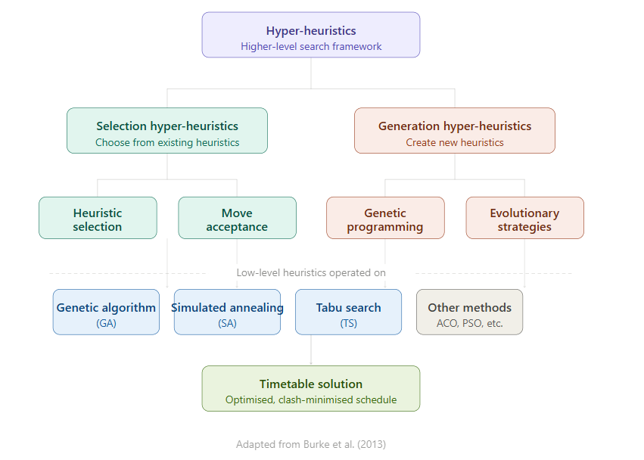
Tabu search is known for efficiently escaping from the local optima, thanks to memory structures. Other recent variants also include long-term memory and frequency-based diversification, attaining competitive results on the ITC-2007 benchmarks. For instance, in 2022, an adaptive tabu search used dynamic tabu tenure and solved course timetabling with uncertain student numbers, achieving solutions with no hard violations 95% of the time (Lü& Hao, n.d.). In another more recent work, also in 2018, TS with adaptive heuristic ordering has reduced soft violations by up to 40% on exam timetabling variants compared to fixed-order-based methods.

Figure 2.1: Broad Categorization of Hyper-Heuristics for Timetabling

2.4 Review of Hyper-heuristic Approaches
While low-level heuristics search directly for solutions, hyper-heuristics operate at a higher level by either selecting or generating low-level heuristics. Selection hyper-heuristics have reported good performance in timetabling, mainly due to their ability to adapt during the search process (Pillay, 2016a). A 2020 review indicated that in 70% of cross-domain tests, hyper-heuristics outperform single metaheuristics owing to their generality (J. H. and K. A. and {\"O}zcan, E. and B. E. K. Drake, 2020).
Simulated annealing (SA) gives good results with fewer parameters to tune. Adaptive cooling schedules and neighborhood structures tailored to timetabling constraints can further reduce computation time while preserving feasibility (Kiefer et al., 2017).Variants with iterative improvement solve curriculum-based problems, reaching 98% feasibility on real datasets, outperforming basic SA by 22% in terms of penalty reduction (Kiefer et al., 2017).
Tabu search (TS) efficiently escapes local optima thanks to memory structures. Recent variants include long-term memory and frequency-based diversification, achieving competitive results on ITC-2007 benchmarks (Lü & Hao, n.d.). Adaptive TS methods with dynamic tenure reduce soft violations and handle uncertain student numbers effectively.

2.5 Review of Natural Language Processing in Scheduling and Optimization
NLP is changing how constraints are input into optimization systems, converting casual text into structured rules. Recent systematic reviews show that rule-based NLP, employing techniques like regular expression (regex) pattern matching, remains a highly effective method for requirements formalization. These deterministic approaches provide 100% accuracy within a predefined vocabulary and avoid the computational overhead associated with deep learning models (Nguyen et al., 2021). Recent work focuses on employee and appointment scheduling but translates well to universities.
While some advanced systems have begun exploring transformer-based models like BERT or Large Language Models (LLMs) to handle ambiguous constraints ((Liu et al., n.d.), rule-based constraint extraction is often preferred for academic and structural prototyping. Using deterministic parsing ensures that explicit institutional rules, such as "No overlapping classes for lecturers," are translated into formal machine-readable constraints without the probabilistic errors common in generative models.

2.6 Conceptual Review (Concepts and Definitions)

2.6.1 Hyper-heuristics
Hyper-heuristics are search methods that choose or create heuristics to solve a problem instead of solving it directly. Selection hyper-heuristics are the most common type for timetabling and typically include a heuristic selection mechanism and a move acceptance criterion (J. H. and K. A. and {\"O}zcan, E. and B. E. K. Drake, 2020; Ochoa, 2012)

2.6.2 Optimization and NP-Hard Problems
According to predetermined goals, optimization entails selecting the best or nearly best option from a wide range of options. As a classic NP-hard optimization problem, university course scheduling cannot be solved in polynomial time by any known algorithm (Pillay, 2016a) Real-world scenarios with hundreds of courses, lecturers, rooms, and other rules quickly render precise methods impracticable, and even figuring out whether a feasible schedule exists (ignoring soft constraints) is NP-complete (Ceschia, 2023; Thepphakorn & Pongcharoen, 2020). Heuristic and meta-heuristic approaches predominate due to this complexity, exchanging guaranteed optimality for good solutions in a reasonable amount of time (J. H. and K. A. and {\"O}zcan, E. and B. E. K. Drake, 2020).

2.6.3 Web-based Timetabling Systems
Modern web-based timetabling systems are increasingly shifting toward rapid prototyping frameworks natively integrated with Python's data science ecosystem. Frameworks like Stream lit and Fast API allow for seamless bridging between the backend optimization engine and the frontend interface without requiring separate JavaScript architectures. These setups provide automatic API documentation, interactive data visualization, and real-time schedule adjustments within a unified ecosystem (Ceschia, 2023).

2.6.4 Hard constraints
This is defined as the conditions that must be satisfied for the timetable to be valid. These include:
  - No lecturer can teach two different courses at the same time.
  - No student group should have two courses scheduled simultaneously.
  - Classrooms must meet capacity requirements.

2. 6.5 Soft constraints
These are the desirable preferences that improve timetable quality but whose violations do not invalidate the schedule. Examples include:
  - Lecturer preferred time slots.
  - Minimizing idle gaps between a student’s classes.
  - Ensuring compact schedules and convenient room locations for lecturers.
The timetabling problem is NP-hard, meaning the solution complexity increases exponentially with the number of courses, lecturers, and rooms involved, making manual and exact mathematical approaches inefficient for real-world cases (Abdipoor et al., 2023b)
UCTP complexity becomes even greater in institutions offering:
- hybrid learning delivery (face-to-face + online),
- multi-section courses,
- large enrolment student groups,
which broadens the search space and produces more optimization conflicts (Dunke & Nickel, 2023; Xiang et al., 2024).
2.7 Theoretical Review (Theories, Models, and Algorithmic Foundations)
Timetabling problems were originally solved using exact methods, such as integer linear programming and constraint programming. Although mathematically powerful, these approaches struggle to scale when the number of constraints increases significantly.
To overcome this limitation, researchers introduced metaheuristic approaches, which search for good solutions rather than perfect solutions within reasonable time. These approaches include:
- Genetic Algorithms (GA)
- Tabu Search (TS)
- Simulated Annealing (SA)
- Ant Colony Optimization (ACO)
- Particle Swarm Optimization (PSO)
However, no single optimization method consistently performs best across all institutions. This gave rise to hyper-heuristics, which are higher-level frameworks that select or generate heuristics dynamically depending on the current state of the solution space. This makes them:
- more flexible across institutions with different constraints,
- easier to scale to large instances,
- more suitable for real-time updates.
Multi-objective optimization has recently been introduced to address conflicting needs, such as room stability versus lecturer travel time, especially in large universities with distributed campuses (Dunke & Nickel, 2023). Modern theoretical models now incorporate dynamic objectives reflecting real university behaviour, including semester timetable changes, venue flexibility, and hybrid teaching policies (Xiang et al., 2024).
The shift in theory highlights the importance of the following:
- scalability,
- adaptivity,
- computational speed,
with expectations that solutions be produced under 10 minutes for medium-sized timetables (Pillay, 2016a).

2.8 Empirical Review (Existing Systems, Findings & Evidence from Studies)
Early research relied heavily on benchmarks, especially the Toronto and ITC-2007 datasets, to compare algorithm performance. Curriculum-based timetabling became particularly difficult due to ever-changing enrolment patterns that caused even initial timetables to become infeasible (Abdipoor et al., 2023b)
Across many implementations, user satisfaction with the timetable depends strongly on soft constraint performance. For example, minimizing idle gaps between classes significantly increases acceptance among lecturers and students (Xiang et al., 2024).
Recent empirical studies report that:
- Optimizing room stability reduces lecturer stress and movement (Dunke & Nickel, 2023).
- Hybrid-teaching models introduce new venue constraints; ignoring these results in 20–30% more soft constraint violations, showing the need for updated models (Xiang et al., 2024).
- Adaptive or real-time timetabling systems perform better in institutions with frequent changes, course additions, or lecturer withdrawal(Pillay, 2016a).
Overall, existing systems suggest that hybrid timetabling methods, combining multiple heuristics and dynamic constraint handling, provide the most balance between feasibility, solution quality, and computational speed.

2.9 Existing Works
Few studies evaluate "algorithm portfolio" strategies when the constraints are derived from natural language prompts instead of pre-defined structured data. While individual metaheuristics have been thoroughly compared on common benchmarks, running multiple algorithms simultaneously to select the virtual best solver, an approach known as competitive algorithm selection, provides a more robust way to handle diverse constraint patterns extracted from text (J. H. Drake et al., 2020)
Furthermore, rather than addressing the intricate multi-constraint university course scheduling problem, the majority of prompt-based scheduling tools concentrate on meeting spaces or straightforward resource allocation. Additionally, not much research has been done on giving end users comparative feedback regarding which algorithm worked best for their particular prompt (J. H. and K. A. and {\"O}zcan, E. and B. E. K. Drake, 2020)
By developing a comprehensive system that accepts English prompts, extracts constraints using rule-based NLP techniques, runs a portfolio of algorithms (GA, SA, and TS), and reports comparative performance, this project fills in these gaps. It provides both a useful tool and empirical insights into algorithm robustness and competitive selection under real-world language-driven inputs.

2.10 Summary of Literature Review
According to (Babaei et al., 2015; Ceschia, 2023), the review demonstrates that university course scheduling is a well-known NP-hard optimization problem that cannot be solved optimally in a reasonable amount of time for real-world instances. Due to this complexity, over the past ten years, meta-heuristic and hyper-heuristic approaches have dominated the field. On benchmarks like ITC-2007 and ITC-2011, genetic algorithms, simulated annealing, tabu search, and particularly selection hyper-heuristics consistently produce high-quality, workable timetables (Abdipoor et al., 2023b; Pillay, 2016a; Soria-Alcaraz, 2015)
Although these algorithms perform well when constraints are supplied in structured formats, very few studies have explored their behaviour when constraints are extracted from natural language prompts. Existing natural-language-driven scheduling systems tend to focus on simpler domains than the multi-constraint university course timetabling problem, and almost none compare multiple algorithms in a portfolio under language-driven inputs.et al., 2021a; Milani Fitria, 2023)(Ahmed et al., n.d.; Pillay, 2016b)
This gap is significant for a management information systems final-year project in the CIS department, as the guidelines explicitly require the application of a computing technique or algorithm to solve a discovered problem and the delivery of a working system. This project now fills this gap by applying modern NLP techniques that convert free-text prompts into formal constraints, comparing the performance of three established hyper heuristic algorithms, genetic algorithm, simulated annealing, and tabu search, on the same prompt-derived instances, and presenting results via an interactive web interface.

CHAPTER THREE

RESEARCH METHODOLOGY

3.1 Preamble
This chapter provides a comprehensive account of the methodology adopted in the design, development, and evaluation of the hyper-heuristic university timetable generation system described in this study. The system, titled "From Prompt to Timetable: Integrating Natural Language Reasoning with Different Hyper-Heuristic Algorithms," was built as a software artifact that accepts academic scheduling data and natural language constraints and then applies three competing meta-heuristic optimization algorithms to produce a conflict-minimized university timetable.
The research adopts the Design Science Research (DSR) methodology, which is appropriate for studies that involve the design, construction, and evaluation of novel IT artifacts intended to solve clearly defined organizational problems (Dresch, 2015). Within DSR, this project is classified as a mixed design: it combines applied design (the construction of a functioning system) with evaluator design (the systematic experimental comparison of three optimization algorithms on real institutional data). This dual nature means that the methodology chapter serves two purposes: it documents the artifact design and implementation decisions, and it states the evaluation strategy that will be assessed in Chapter Four.
The remainder of this chapter is structured as follows. Section 3.2 states the research design. Section 3.3 describes the data source and data collection process, including an honest account of the dataset's limitations. Sections 3.4 to 3.9 present the system analysis, architecture, input/output design, and database design. Sections 3.10 to 3.14 specify the constraint model, fitness function, initial solution generation, algorithm designs, and natural language processing module. Sections 3.15 to 3.17 cover the UML models, software requirements, and implementation procedures. Section 3.18 states the evaluation strategy. Section 3.19 summarizes the chapter.

3.2 Research Design
The research design adopted for this study is the Design Science Research (DSR) methodology. DSR is a problem-solving paradigm that prescribes the construction and evaluation of purposeful artifacts, in this case, a software system, to address identified organizational problems (Dresch, 2015). The methodology is particularly suitable for this project for the following reasons.
First, the university timetable scheduling problem (UTSP) is a clearly identified, well-documented organizational problem. It is classified in the theoretical computer science literature as NP-hard, meaning that no known polynomial-time algorithm can find the globally optimal solution for real-world instances (Ceschia, 2023). This justifies the use of meta-heuristic methods, which produce good-quality solutions within acceptable computational time rather than guaranteeing mathematical optimality.
Second, the primary output of this project is a novel software artifact, an intelligent, web-based timetable generation system that integrates natural language constraint specification with a hyper heuristic optimization framework. The construction of this artifact constitutes the applied design component of the research.
Third, the artifact is systematically evaluated through controlled experiments. Three meta-heuristic algorithms, the Genetic Algorithm (GA), Simulated Annealing (SA), and Tabu Search (TS), are applied to the same scheduling problem, and their performance is compared using quantitative metrics including fitness score, clash counts, and execution time. This constitutes the evaluator design component of the research.
The study therefore follows a mixed research design: applied design in the construction of the artifact and evaluator design in the experimental comparison of algorithms. This classification aligns with the project guidelines for mixed design projects, which combine development and evaluation.

3.3 Population, Data Source, and Data Limitations

3.3.1 Data Collection Process and Limitations
The primary dataset used in this study is the Covenant University Academic Resources Dataset, which was assembled specifically for this project. The target data represented the full academic scheduling information for the 2025/2026 academic session at Covenant University, Ota, Ogun State, Nigeria, covering course codes, assigned lecturers, enrolled student counts, assigned teaching venues, and course load information across all colleges and departments.
Data was collected from multiple sources, including the Directorate of Academic Planning Unit (DAPU), timetable records obtained from individual departments, and direct departmental scheduling documents. However, the data collection process encountered significant limitations. The university does not maintain a single, centralized, machine-readable scheduling database accessible to undergraduate researchers. As a result, records from different departments were supplied in inconsistent formats; some were incomplete, and others contained missing or ambiguous entries for lecturer names, venue capacities, and student enrollment figures.
To address these gaps, supplementary data was added by the researcher based on institutional knowledge as a registered student of Covenant University. Where official lecturer names were unavailable, placeholder names or names drawn from publicly known departmental staff were used. Where venue capacities could not be confirmed from official records, estimates were made based on physical familiarity with the venues and standard university venue configurations. Where course entries were missing student counts, reasonable estimates were inserted based on class sizes typically observed at the department and level in question.
It is therefore important to acknowledge that the dataset used in this study is a partially estimated dataset. While every effort was made to ensure that the figures are realistic and internally consistent, the generated timetable, though algorithmically optimized given the input data, may not perfectly reflect true institutional scheduling constraints in every respect. The accuracy of the output is bounded by the accuracy and completeness of the input. This limitation is discussed further in Chapter Five.

3.3.2 Dataset Characteristics
After collection, cleaning, and supplementation, the dataset used for this study has the following characteristics:
Property | Value
File Format | CSV (Comma-Separated Values)
Total Records | 490+ course sessions
Unique Departments | 20+ academic departments
Academic Levels | 100, 200, 300, 400, 500
Unique Venues | 50+ classroom venues
Unique Lecturers | 100+ academic staff
Student Count Range | 56 to 431 per course
Course Load Range | 1 to 3 hours per session
Table 3.1: Covenant University Academic Dataset Characteristics

3.3.3 Venue Classification
The venues in the dataset are classified into the following categories based on physical capacity and function:
Category | Examples | Capacity Range
Mega Lecture Theatres | LT1, LT2, LARGE LH | 1,000 – 2,500
Large Halls | HALL107, HALL108, HALL201 | 240 – 500
Medium Halls | HALL306, HALL307, STUDIO100 | 180 – 280
Science Laboratories | BCH_LAB, BIO_LAB, CHEM_LAB | 140 – 180
Computer Laboratories | COMPUTER_LAB | 250 – 300
Engineering Lecture Halls | CHE 200LH, CVE 300LH, MCE 400LH | 150 – 250
Special Venues | CBN_AUDITORIUM, CHAPEL, LIBRARY | 500 – 1,200
Overflow Facilities | OVERFLOW_HALL_1, OVERFLOW_HALL_2 | 800 – 1,000
Table 3.2: Venue Classification and Capacity Ranges

3.3.4 Data Preprocessing Pipeline
Before the dataset is loaded into the scheduling engine, it passes through a rigorous preprocessing pipeline implemented in the load_dataset() function within engine.py. The pipeline performs the following steps:
(i)Column Name Standardization: All column names are stripped of leading and trailing whitespace and mapped to a set of recognized standard names. For example, columns named "LECTURERS," "LECTURER'S NAME," or "LECTURER NAME" are all mapped to the standard "LECTURER" column. This ensures that datasets from different departments with varying column naming conventions can all be processed by the same engine without manual reformatting.
(ii) Missing Lecturer Assignment: For course records where the lecturer field is missing, blank, or contains placeholder values such as "Unknown" or "N/A," the system assigns a placeholder Nigerian academic name drawn from a predefined pool of realistic names within the engine configuration. This prevents the scheduling engine from failing due to missing lecturer entries while maintaining a realistic institutional appearance in the output.
(iii) Student Count Cleaning: Non-numeric student count values are coerced to numeric. Records with completely missing course codes are removed. Records where student count exceeds 1.5 times the venue's known capacity are flagged and removed as likely data entry errors.
(iv) Venue Capacity Mapping: Each venue name in the dataset is mapped to its seating capacity. Where the dataset includes an explicit venue capacity column, those values are used directly and stored in the engine's VENUE_CAPACITY dictionary. Where no capacity data is available, the engine applies a name-heuristic function that infers approximate capacity based on the venue name pattern.
(v) Venue Key Standardization: Venue names are converted to uppercase, spaces are replaced with underscores, and special characters are removed to create consistent dictionary keys for the scheduling engine's room tracking logic.
(vi) Dataset Summary: Upon completion of preprocessing, the engine prints a summary of the total courses loaded, unique venues, unique lecturers, and maximum student count, allowing the administrator to verify the data before initiating optimization.
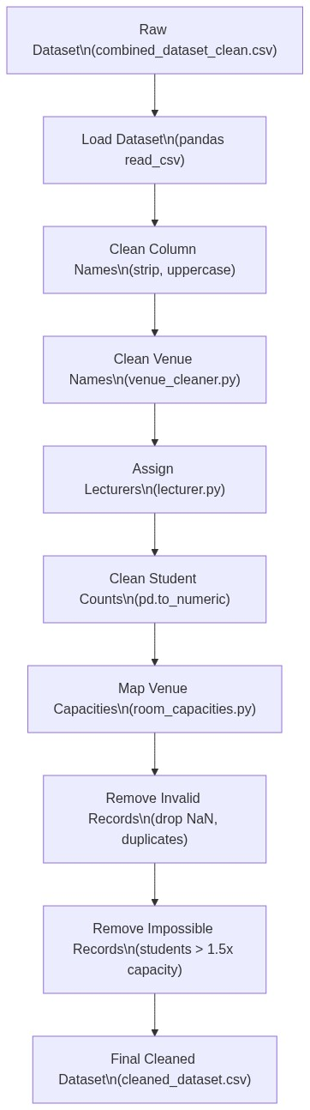
Figure 3.1: Data Preprocessing Pipeline Flowchart

3.4 System Analysis

3.4.1 Analysis of the Existing System
Traditional university course timetabling at most Nigerian institutions, including Covenant University, is conducted through manual or semi-manual spreadsheet-based processes. Academic administrators from individual departments compile course lists, lecturer assignments, and room preferences into spreadsheet files, which are then manually reconciled across departments by timetabling officers. This process suffers from several well-documented limitations.
High Error Rate: Manual scheduling is inherently prone to human error. Lecturer clashes, room conflicts, and capacity violations are common outcomes of manual processes and typically require multiple iterations of correction (Enami et al., 2019).
Time Intensity: The manual process typically requires several weeks of iterative adjustment before a viable timetable is produced, competing with other administrative responsibilities and introducing scheduling delays at the start of each semester.
Scalability Failure: As the number of courses, lecturers, venues, and enrolled students grows, the combinatorial complexity of the scheduling problem increases exponentially. Manual approaches cannot effectively explore the large solution space and often settle for the first feasible solution found rather than an optimized one (Ceschia, 2023).
No Optimization: The existing system produces timetables that are feasible at best. There is no mechanism for optimizing quality metrics such as minimizing the number of late-evening sessions, distributing classes evenly across the week, or respecting individual lecturer scheduling preferences.
No Natural Language Interface: Institutional scheduling policies and lecturer preferences must be translated by the timetabling officer into rigid spreadsheet formats. There is no facility for expressing constraints in ordinary English, which creates a communication barrier between non-technical administrators and the scheduling process.

3.4.2 Analysis of the Proposed System
The proposed system addresses each of the above limitations through an intelligent, automated scheduling platform. Natural language constraint specification allows administrators to input scheduling constraints as plain English sentences. The system's NLP module, implemented in nlp_parser.py, parses these sentences using regular expression pattern matching and converts them into structured JSON constraint objects that the scheduling engine applies directly.
Multi-Algorithm Hyper-Heuristic Optimization: Three optimization algorithms, GA, SA, and TS, are executed in sequence on the same scheduling problem. The algorithm producing the lowest fitness score is automatically selected as the final timetable. This hyper-heuristic approach ensures that the best-available solution is always delivered, regardless of which algorithm happens to perform best for a particular problem instance (J. H. Drake et al., 2020).
Automated Clash Detection: The fitness function, implemented in the evaluate_timetable() function of engine.py, systematically detects and lecturer clashes, room double-bookings, capacity violations, unscheduled sessions, and NLP constraint violations using a weighted penalty model.
Web-Based Interface: With real-time timetable visualization, a multi-step generating workflow, and CSV export capabilities, a frontend powered by Streamlit offers role-based access for three user types: academic administrators, lecturers, and students. Programmatic access to the scheduling engine is made possible by a FastAPI backend server using clearly specified RESTful API endpoints.

3.5 Proposed System Description

3.5.1 System Overview
The proposed system is a multi-layered intelligent timetable scheduling platform. The system accepts academic resource datasets in CSV format, parses natural language constraints submitted by administrators, generates an initial feasible timetable using a greedy constructive heuristic, and then applies three competing meta-heuristic optimization algorithms to produce an optimized, clash-minimized schedule. The algorithm producing the best result is selected automatically by the hyper-heuristic selection mechanism.
The system operates through a four-step administrator workflow: (1) Dataset Upload, (2) Hard Constraint Definition, (3) Soft Constraint Definition, and (4) Multi-Algorithm Optimization.

3.5.2 Key System Features
Feature | Description
NLP Constraint Parsing | Translates plain English constraints into structured JSON using regex pattern matching
Genetic Algorithm | Population-based evolutionary search with tournament selection, single-point crossover, elitism, and mutation
Simulated Annealing | Temperature-based probabilistic neighbourhood search with geometric cooling schedule
Tabu Search | Memory-based neighbourhood search with a tabu list to prevent cycling
Fitness Evaluation | Multi-objective weighted penalty function detecting six violation categories
Hyper-Heuristic Selection | Automatic selection of best-performing algorithm by minimum fitness score
Role-Based Access | Separate access portals for administrators, lecturers, and students
Real-Time Visualisation | Interactive weekly grid explorer with day-by-day tabbed timetable views
Manual Override | Administrator ability to adjust individual course assignments post-optimisation
CSV Export | Download functionality for the optimised timetable in CSV format
RESTful API | FastAPI backend with endpoints for upload, constraint parsing, and generation
Table 3.3: Key Features of the Time4Tables System

3.6 System Architecture
The system follows a three-tier client-server architecture comprising a Presentation Layer, a Business Logic Layer, and a Data Layer.
The Presentation Layer is implemented using Streamlit (app_ui.py), a Python-based rapid web application framework. Streamlit was chosen because it allows Python data science code and interactive UI elements to be combined in a single codebase, eliminating the need for a separate frontend language.
The Business Logic Layer is implemented using FastAPI (app.py), a modern Python web framework that provides automatic OpenAPI documentation, type validation, and asynchronous request handling. The scheduling engine (engine.py), the three algorithm modules, and the NLP parser (nlp_parser.py) all reside in this layer.
The Data Layer uses SQLite as the embedded relational database, accessed through the SQLAlchemy Object-Relational Mapping (ORM) library. SQLite was selected for its zero-configuration requirement, suitability for single-user deployment, and seamless integration with Python's data science ecosystem.

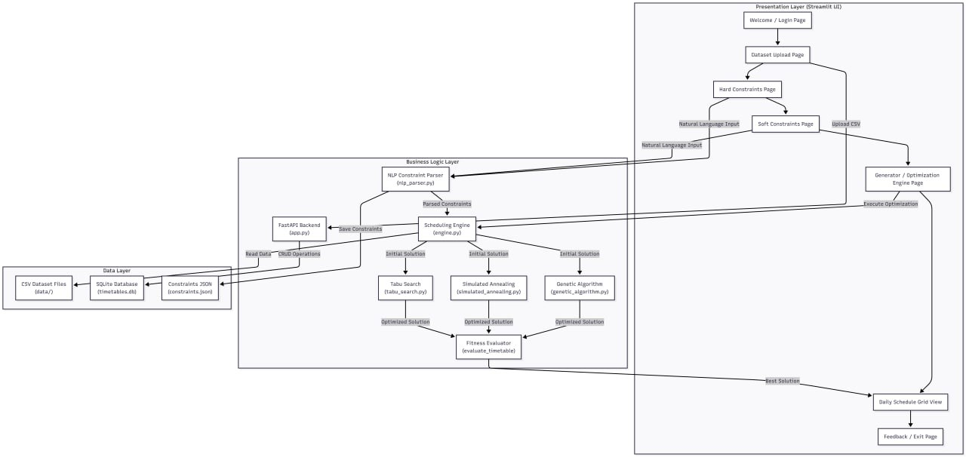
Figure 3.2: High-Level System Architecture Diagram

3.7 Input Design

3.7.1 Academic Resource Dataset (CSV)
The first input is a Comma-Separated Values (CSV) file containing the academic scheduling data for the semester. The following columns are expected:
Column Name | Data Type | Description | Example
SEMESTER | String | Academic semester identifier | Alpha
LEVEL | Integer | Student academic level | 100, 200, 300
COURSE CODE | String | Unique course identifier | CSC335, BCH357
COURSE LOAD(HOURS) | Integer | Weekly contact hours | 1, 2, 3
COURSE UNIT | Integer | Credit units | 2, 3
CLASSROOM (VENUE) | String | Preferred or assigned venue | COMPUTER_LAB
COURSE TITLE | String | Full course name | Data Structures
LECTURER | String | Assigned lecturer name | Dr. Dada
STUDENTS | Integer | Number of enrolled students | 176
VENUE_CAPACITY | Integer | Maximum seating capacity of venue | 250
Table 3.4: Academic Resource Dataset Column Specifications

3.7.2 Natural Language Constraints
The second input category is plain English text entered by the administrator through the user interface's Hard Constraint and Soft Constraint text areas. Hard Constraint examples include: "No lecturer should teach two classes at the same time", "No overlapping classes for lecturers", and "Large classes above 200 students must use big halls." Soft Constraint examples include: "Morning classes are preferred", "Avoid evening classes", "No classes on Friday", "Dr. Rotimi cannot teach on Monday", and "No late Friday classes."
The parser merges hard and soft constraint inputs through the merge_constraints() function, which combines both parsed outputs into a single unified constraint dictionary. Hard constraint avoid_days and avoid_timeslots entries take precedence over soft constraint entries for the same keys.

3.8 Output Design
The system produces four output types after optimization: (1) Optimized Timetable as a CSV file (final_timetable.csv), (2) Fitness Evaluation Report as a Python dictionary containing all violation counts, (3) Algorithm Comparison Benchmark as a table showing each algorithm's fitness score, execution time, and selection status and (4) Interactive Visual Timetable displayed as a Streamlit-based weekly grid explorer with day-by-day tabbed views.

3.9 Database Design

3.9.1 Database Technology
The system uses SQLite as the embedded relational database, accessed through the SQLAlchemy ORM library. SQLite was chosen for its lightweight nature, zero-configuration requirement, portability as a single file (timetables.db), and suitability for local desktop and web application deployment without requiring a database server.

3.9.2 Database Schema
Column | Data Type | Constraints | Description
ID | INTEGER | PRIMARY KEY, AUTO INCREMENT | Unique record identifier
course | VARCHAR | INDEXED | Course code
lecturer | VARCHAR | — | Lecturer name
students | INTEGER | — | Enrolled student count
venue | VARCHAR | — | Assigned classroom venue
time slot | VARCHAR | — | Assigned day and hour
duration | INTEGER | — | Duration in hours
level | VARCHAR | — | Student academic level
Table 3.5: Database Schema - timetable_entries Table
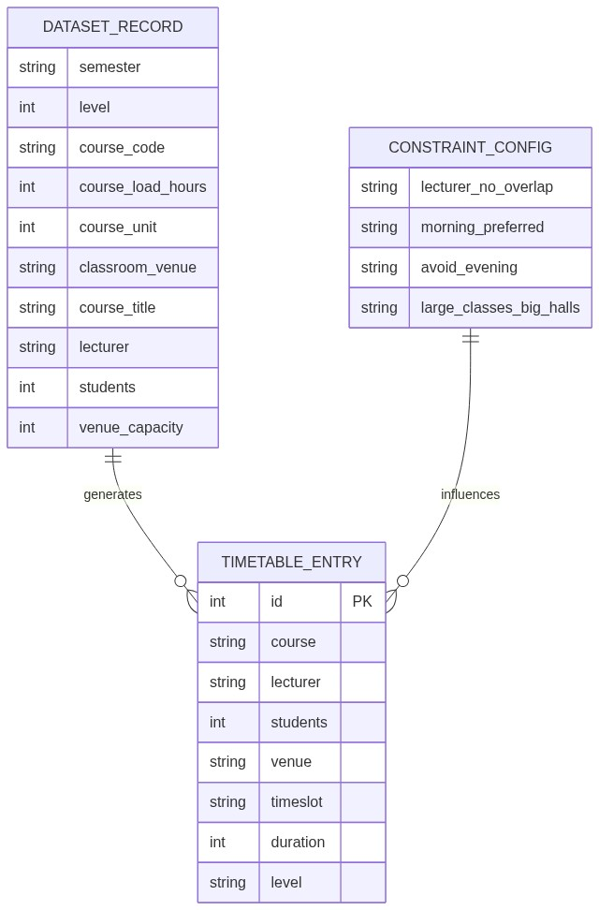
Figure 3.3: Entity-Relationship Diagram (ERD)

3.10 Constraint Definition

3.10.1 Hard Constraints
Hard constraints are inviolable conditions that must be satisfied for a timetable to be considered feasible. Their violation is penalized with high weight values in the fitness function, ensuring that the optimization algorithms strongly prioritize their elimination:
ID | Constraint | Description | Penalty Weight
HC1 | Lecturer Non-Overlap | A lecturer cannot be assigned to two or more courses in the same timeslot | 100,000 per violation
HC2 | Room Non-Overlap | A classroom cannot host two or more courses in the same timeslot | 100,000 per violation
HC3 | Capacity Compliance | The number of enrolled students must not exceed the room's seating capacity | 50,000 per violation
HC4 | Session Scheduling | Every course must be assigned a valid timeslot and venue | 500,000 per unscheduled session
Table 3.6: Hard Constraints and Penalty Weights

3.10.2 Soft Constraints
Soft constraints represent preferences that should be satisfied when possible but do not invalidate the timetable if violated. They are derived from the NLP-parsed administrator input and are penalized with a lower weight to guide, rather than force, the search:
ID | Constraint | Description | Penalty Weight
SC1 | Day Avoidance | Certain days should be avoided for scheduling | 5,000 per violation
SC2 | Timeslot Avoidance | Specific timeslots should be excluded | 5,000 per violation
SC3 | Morning Preference | Classes should preferably be scheduled in morning timeslots (8am–1pm) | 5,000 per evening violation
SC4 | Evening Avoidance | Late timeslots (4–5, 5–6) should be avoided | 5,000 per violation
SC5 | Lecturer Day Preference | Specific lecturers should not be scheduled on specific days | 5,000 per violation
SC6 | Large Hall Requirement | Courses above a student threshold must be in large halls | 10,000 per violation
Table 3.7: Soft Constraints and Penalty Weights

3.10.3 Special Constraints
ID | Constraint | Description
SP1 | Computer Course Preference | Courses with prefixes CSC, CIT, or CIS are preferentially assigned to COMPUTER_LAB
SP2 | Level 500 Restriction | 500-level courses are not scheduled in late timeslots (4–5 or 5–6)
SP3 | GST/EDS Course Routing | Courses with prefixes GST or EDS are preferentially routed to large lecture theatres (LT1, LT2)
SP4 | Chapel Routing | Courses with prefixes TMC or DLD are assigned to the CHAPEL venue
Table 3.8: Special (Domain-Specific) Constraints

3.11 Fitness Function Design

3.11.1 Mathematical Formulation
The fitness function evaluates the quality of a timetable solution by computing a weighted sum of all constraint violations. A lower fitness value indicates a better, more feasible solution. The fitness function is defined as:
F(T) = w₁ × V_LC + w₂ × V_RC + w₃ × V_CV + w₄ × V_PV + w₅ × V_US + w₆ × V_NLP
Symbol | Description | Weight (wᵢ)
V_LC | Number of lecturer clash instances | w₁ = 100,000
V_RC | Number of room clash instances | w₂ = 100,000
V_CV | Number of capacity violations | w₃ = 50,000
V_PV | Number of practical session violations | w₄ = 10,000
V_US | Number of unscheduled sessions | w₅ = 500,000
V_NLP | Number of NLP soft constraint violations | w₆ = 5,000
Table 3.9: Fitness Function Penalty Weights

3.11.2 Violation Detection Logic
(1) Lecturer Clash Detection (V_LC): The engine maintains a dictionary tracking the number of courses each lecturer is assigned per timeslot. For each lecturer-timeslot combination with a count greater than one, the excess (count − 1) is added to the lecturer clash penalty. V_LC = Σ Σ max(0, count − 1).
(2) Room Clash Detection (V_RC): The same logic is applied for rooms. For each room-timeslot combination with more than one course assigned, the excess is counted as a room clash.
(3) Capacity Violation Detection (V_CV): For each scheduled session, if the number of enrolled students Sᵢ exceeds the room capacity Cᵢ, one capacity violation is counted: V_CV = Σ [1 if Sᵢ > Cᵢ, else 0].
(4) NLP Soft Constraint Violation Detection (V_NLP): For each session, the engine checks against the parsed constraint dictionary — whether the assigned day is in the avoid_days list, whether the assigned timeslot is in the avoid_timeslots list, whether morning_preferred is active and the session is in an evening slot, and whether any named lecturer is scheduled on their declared avoid_day.
(5) Unscheduled Sessions (V_US): Sessions that could not be assigned any valid timeslot and room after two scheduling passes are flagged as UNSCHEDULED, and each unscheduled session incurs the highest penalty weight of 500,000.

3.11.3 Weight Justification
The penalty weights are hierarchically assigned based on the severity of each violation. Unscheduled sessions (w₅ = 500,000) receive the highest penalty because they represent a complete failure to fulfil a mandatory academic obligation. Lecturer and room clashes (w₁ = w₂ = 100,000) receive equal high penalties because both types of clashes render the timetable physically impossible. Capacity violations (w₃ = 50,000) are serious but less catastrophic. NLP soft constraint violations (w₆ = 5,000) receive the lowest penalty, reflecting their preferential rather than mandatory nature.
3.12 Initial Timetable Generation
Before meta-heuristic optimization can begin, a valid initial timetable must be constructed. The generate_initial_solution() function in engine.py implements a greedy constructive heuristic that processes courses in descending order of student enrolment (largest classes first). This priority ordering ensures that courses with the highest room capacity requirements are assigned first, before smaller classes have consumed all large-hall slots, thereby reducing the likelihood of subsequent capacity violations.
The function builds a slot ordering list that respects any parsed soft constraints — for example, morning slots are placed at the front of the list if morning_preferred is active, avoided days are placed at the end as fallback only. For each course, the engine iterates through valid rooms (filtered by capacity and course type) and available timeslots until a clash-free assignment is found. If no assignment is possible after the primary pass, a relaxed recovery pass is attempted with all timeslots and all venues available.
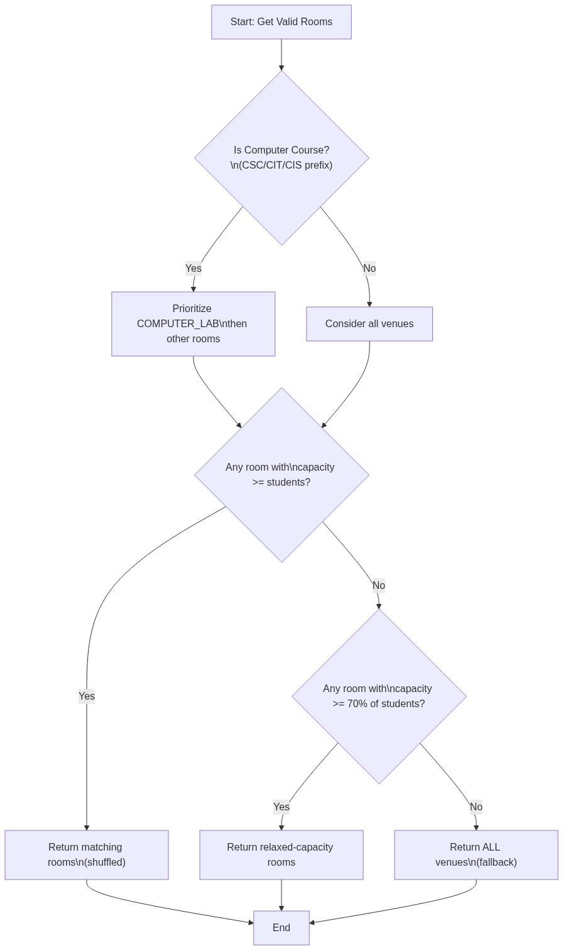
Figure 3.4: Room Selection Strategy Flowchart

3.13 Algorithm Design

3.13.1 Overview of the Hyper-Heuristic Approach
The system employs a selection hyper-heuristic framework, which operates at a higher level of abstraction than individual meta-heuristics. Rather than committing to a single optimization algorithm, the system runs all three algorithms, GA, SA, and TS, on the same scheduling problem with the same initial data and parsed constraints. After all, three runs complete, the system evaluates each algorithm's final solution using the shared fitness function and selects the one with the lowest (best) fitness score as the final output. This approach is justified by (J. H. Drake et al., 2020), who demonstrated that hyper-heuristic portfolio methods outperform single-algorithm approaches on combinatorial optimization problems because the relative performance of algorithms varies across problem instances.

3.13.2 Problem Representation
Each timetable solution is represented as a Python list of dictionaries, where each dictionary encodes one scheduled course session. This unified representation is shared across all three algorithms and the fitness function, enabling direct comparison. A session dictionary contains the following fields: course code, lecturer name, student count, venue name, venue capacity, timeslot (in the format Day_Hour), duration in hours, and student academic level. The search space is defined by the Cartesian product of available timeslots and venues. With 6 days × 10 hours per day = 60 timeslots and approximately 30+ active venues, each course can theoretically be assigned to any of 60 × 30 = 1,800 (day, hour, venue) combinations. With 490+ courses to schedule, the total search space is astronomically large, making exhaustive search computationally infeasible and justifying the use of meta-heuristic approaches.

3.13.3 Genetic Algorithm Methodology
The Genetic Algorithm (GA) is a population-based evolutionary optimization algorithm inspired by Darwinian principles of natural selection and genetic inheritance (Katoch, 2021). In the timetabling context, each individual in the population represents a complete timetable solution, and the algorithm evolves the population toward better solutions through selection, crossover, and mutation operators.
Parameter | Value | Description
Population Size | 50 | Number of timetable solutions maintained per generation
Generations | 200 | Maximum number of evolutionary cycles
Mutation Rate | 0.2 (20%) | Probability of mutating each session
Tournament Size | 5 | Number of individuals in each tournament selection
Elitism Count | 5 | Number of top solutions preserved each generation
Crossover Method | Single-Point | Chromosome split at a random index position
Selection Method | Tournament Selection | Competitive selection among random subsets
Table 3.10: Genetic Algorithm Configuration Parameters
Tournament Selection randomly samples a subset of five individuals from the population and selects the one with the lowest fitness score as a parent. This method provides effective selection pressure while maintaining population diversity, preventing premature convergence to a local optimum.
Single-Point Crossover combines two parent timetables by selecting a random split point. The child timetable inherits all sessions before the split point from Parent 1 and all sessions from the split point onward from Parent 2, potentially producing offspring better than either parent.
Elitism: The top five individuals in the current generation are copied directly to the next generation without modification, guaranteeing that the best solution found is never lost through crossover or mutation.
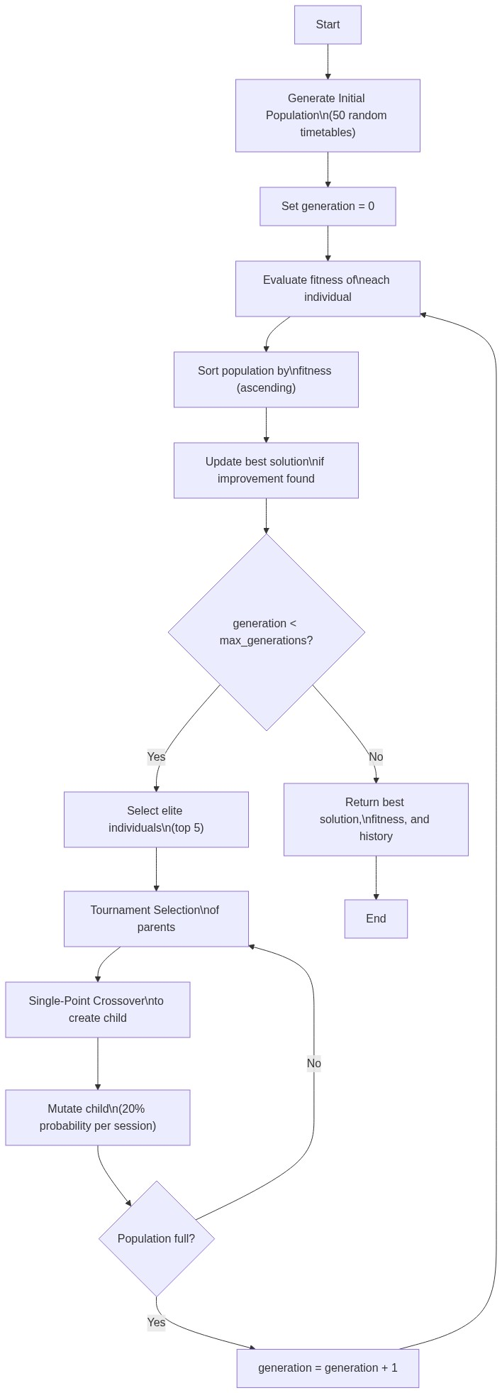
Figure 3.5: Genetic Algorithm Flowchart

3.13.4 Simulated Annealing Methodology
Simulated Annealing (SA) is a probabilistic meta-heuristic inspired by the physical annealing process in metallurgy, where materials are heated and cooled slowly to reduce internal defects (Delahaye, 2018). The algorithm explores the solution space by iteratively generating neighbouring solutions through mutation and accepting or rejecting them based on the Metropolis acceptance criterion.
Parameter | Value | Description
Initial Temperature | 10,000 | Starting temperature controlling exploration
Cooling Rate (α) | 0.995 | Geometric cooling schedule multiplier
Iterations | 500 | Number of search iterations
Minimum Temperature | 0.001 | Floor value preventing division by zero
Mutation Rate | 0.1 (10%) | Probability of mutating each session per iteration
Table 3.11: Simulated Annealing Configuration Parameters
The Metropolis acceptance criterion accepts a worse neighbour solution with probability e^(−ΔE / T), where ΔE is the fitness difference and T is the current temperature. At high temperatures this enables broad exploration; as the temperature decreases through the geometric cooling schedule T(k+1) = α × T(k), the algorithm converges toward exploitation of the best solution found.
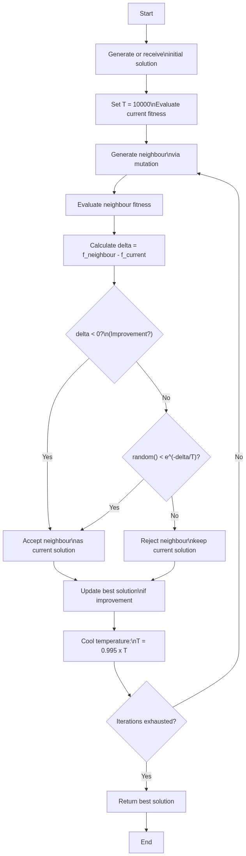
Figure 3.6: Simulated Annealing Flowchart

3.13.5 Tabu Search Methodology
Tabu Search (TS) is a meta-heuristic that uses an adaptive memory structure — the tabu list — to guide the search away from recently visited solutions, preventing cycling and encouraging exploration of new regions of the search space (Sevaux, 2018). In each iteration, TS generates multiple neighbourhood solutions, evaluates each non-tabu candidate, and moves to the best one.
Parameter | Value | Description
Maximum Iterations | 300 | Number of search cycles
Tabu List Size | 30 | Maximum number of signatures stored in tabu memory
Neighbours per Iteration | 20 | Number of candidate neighbour solutions generated each cycle
Mutation Rate | 0.3 (30%) | Higher rate to generate greater neighbourhood diversity
Table 3.12: Tabu Search Configuration Parameters
The tabu list stores solution signatures, compact hashable representations of each visited timetable as a tuple of (course, timeslot) pairs. When evaluating neighbours, any neighbour whose signature is already in the tabu list is skipped. If all generated neighbours are tabu, the aspiration criterion applies: the best among all tabu candidates is accepted regardless of tabu status, preventing the search from stagnating.
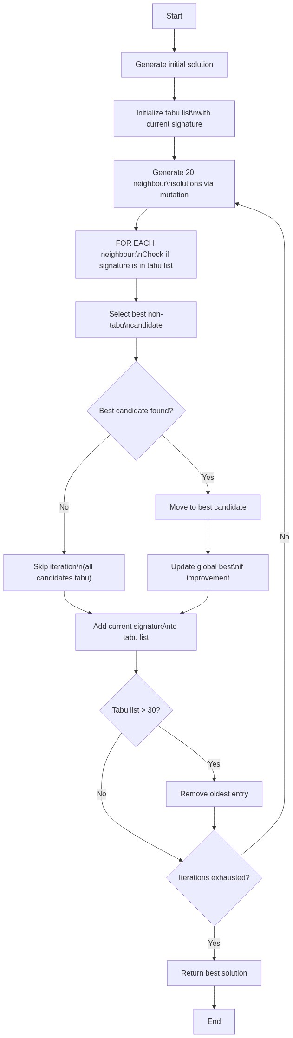
Figure 3.7: Tabu Search Flowchart

3.13.6 Mutation Operator Design
The mutation operator is a shared component used by all three algorithms. It generates neighbouring solutions by modifying approximately 20–30% of sessions (depending on each algorithm's configured mutation rate). Phase 1 - Random Reassignment: Each session is independently selected for mutation with the configured probability. Selected sessions are freed from their current timeslot and room, then reassigned using constraint-aware slot ordering and room selection logic. Phase 2 - Recovery Scheduling: Any sessions that become unscheduled during Phase 1 undergo a recovery pass where all constraints are relaxed to ensure every course receives an assignment and avoids the catastrophic unscheduled penalty.
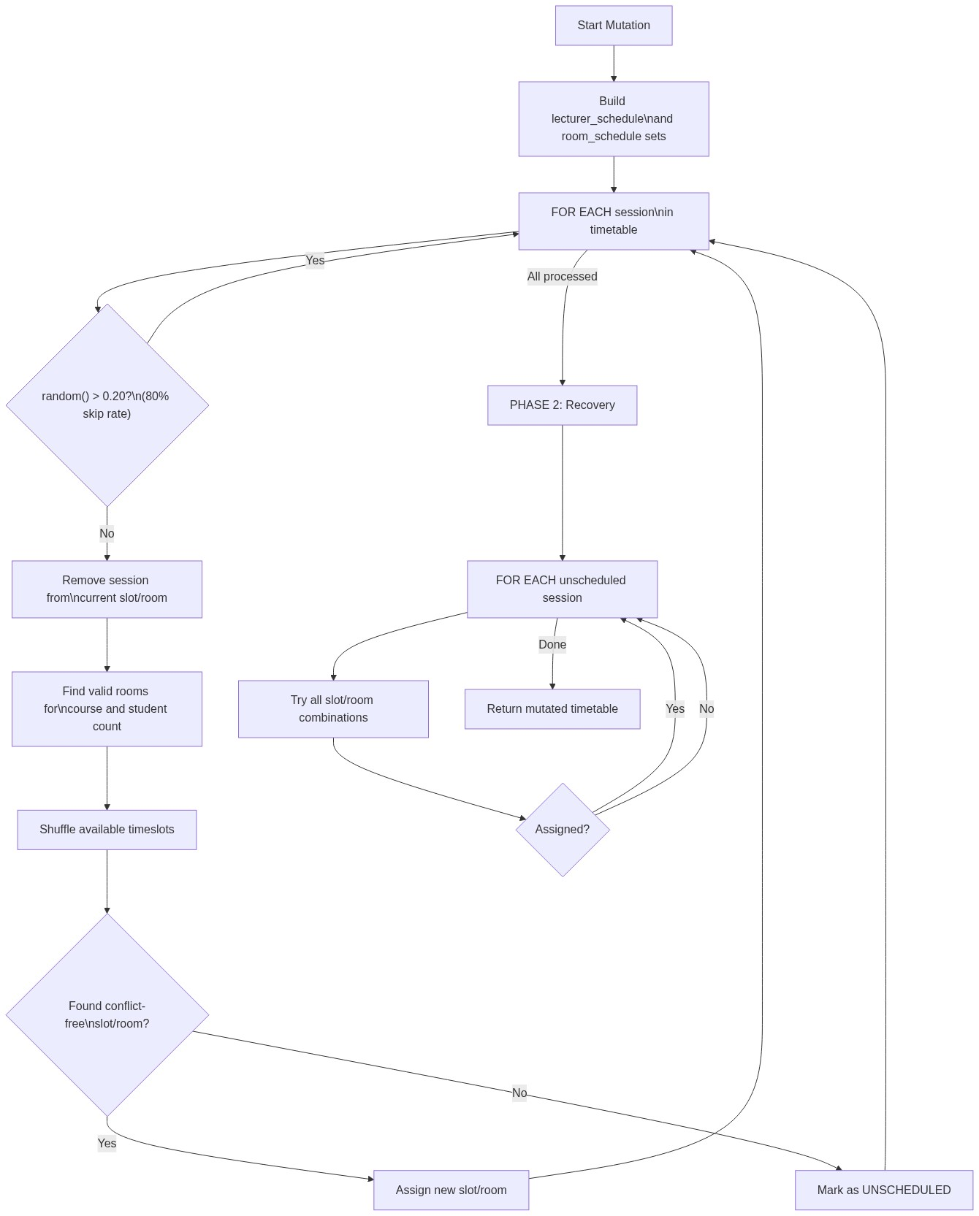
Figure 3.8: Mutation Operator Flowchart

3.13.7 Hyper-Heuristic Selection Strategy
After all, three algorithms have completed their optimization runs, the system compares the final fitness scores and selects the algorithm with the lowest value as the winner. Its timetable solution is presented to the administrator as the final output, and the benchmark comparison table displays all three algorithms' performance metrics side by side for transparency.

3.14 NLP Constraint Parsing Module

3.14.1 Architecture
The NLP module, implemented in nlp_parser.py, operates as a rule-based natural language understanding system that translates English-language constraint specifications into structured Python dictionaries. The module uses Python's built-in re (regular expressions) library exclusively. No external machine learning libraries, transformer models, or pre-trained language models are employed. This design choice was deliberate: (Nguyen et al., 2021) demonstrated that rule-based NLP employing deterministic regex pattern matching provides 100% accuracy within a predefined constraint vocabulary, without the computational overhead or probabilistic errors associated with deep learning models.

3.14.2 Parsing Pipeline
The parse_constraints() function processes input text through the following stages: (1) Text Normalisation - the input string is stripped and converted to lowercase; (2) Day Avoidance Extraction - patterns detecting avoided days ("no classes on Friday from 2pm", "avoid Saturday", etc.) including "weekend" as a shorthand for Saturday and Sunday; (3) Timeslot Avoidance Extraction - time-of-day patterns ("no classes after 7pm", "late Friday afternoon"); (4) Morning Preference Extraction - patterns detecting preference for morning sessions; (5) Evening Avoidance Extraction - softer evening avoidance patterns; (6) Large Class Threshold Extraction - numeric thresholds for large class routing; (7) Lecturer Preference Extraction - individual lecturer scheduling preferences ("Dr. Adebayo should not teach on Mondays") and (8) Constraint Object Assembly - values assembled into a structured Python dictionary.

3.14.3 Hard and Soft Constraint Merging
The merge_constraints() function is called by the API backend to combine the parsed outputs of the hard constraint text area and the soft constraint text area into a single unified constraint dictionary. Hard constraint avoid_days and avoid_timeslots entries take precedence. Boolean preferences are combined with logical OR. Lecturer preferences from both inputs are merged into a single dictionary.
Figure 3.9: NLP Constraint Parsing Pipeline

3.14.4 Supported Constraint Patterns
Category | Example Input Text
Day Avoidance | "No classes on Friday", "Avoid Saturday", "Not on Monday"
Evening Avoidance | "Avoid evening classes", "No late slots", "After 7pm avoid"
Morning Preference | "Morning classes preferred", "Early sessions only"
Large Class Routing | "Large classes above 200 must use big halls"
Specific Timeslot Avoid | "Late Friday afternoon", "No classes after 5pm"
Lecturer Day Restriction | "Dr. Rotimi cannot teach on Monday"
Lecturer Day Preference | "Prof. Bello prefers Tuesdays"
Weekend Avoidance | "No weekend classes"
Table 3.13: Supported NLP Constraint Pattern Categories

3.15 UML Diagrams

3.15.1 Use Case Diagram
The use case diagram (Figure 3.11) identifies three actor types interacting with the system: the Academic Administrator (who uploads data, enters constraints, triggers optimization, views and exports the timetable), the Lecturer (who views their personalized schedule), and the Student (who views a level and department-filtered timetable).
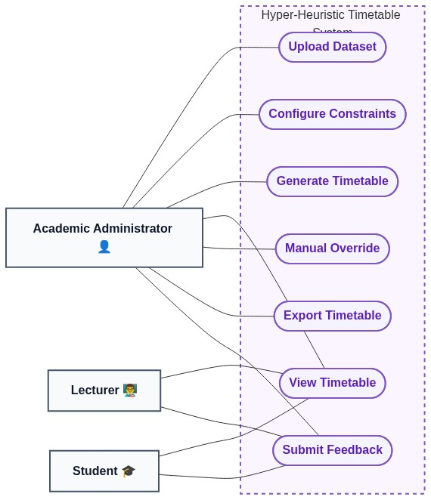
Figure 3.10: Use Case Diagram

3.15.2 Activity Diagram - Timetable Generation Process
The activity diagram (Figure 3.12) models the full workflow from administrator login through dataset upload, constraint entry, initial solution generation, multi-algorithm optimization, and timetable display.
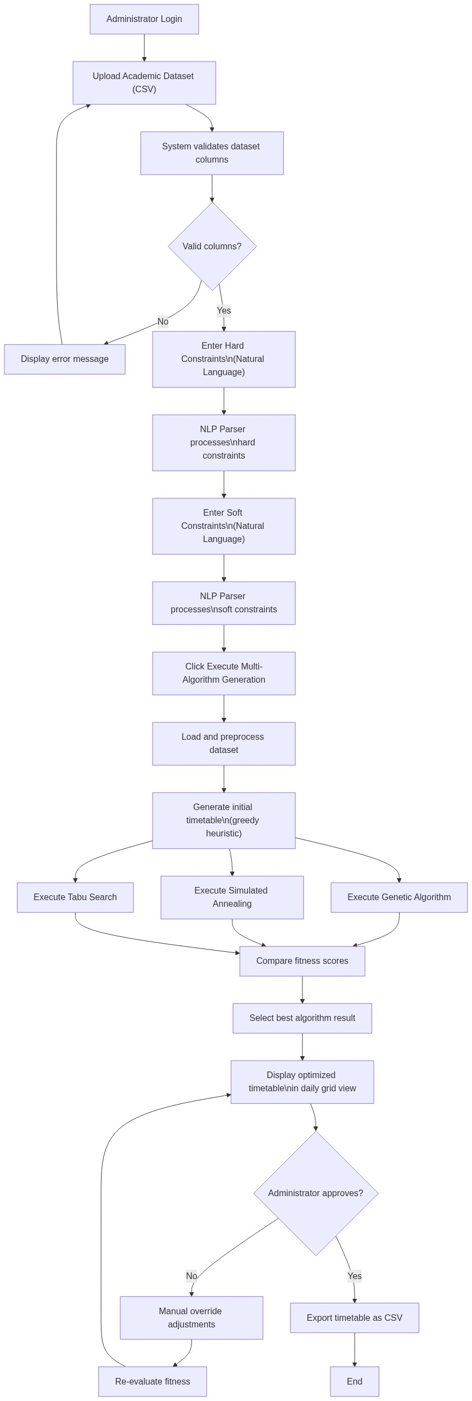
Figure 3.11: Activity Diagram - Timetable Generation Workflow

3.15.3 Sequence Diagram — Optimization Flow
The sequence diagram (Figure 3.13) documents the message flow between the Streamlit UI, the FastAPI backend, the scheduling engine, and the three algorithm modules during the optimization process.
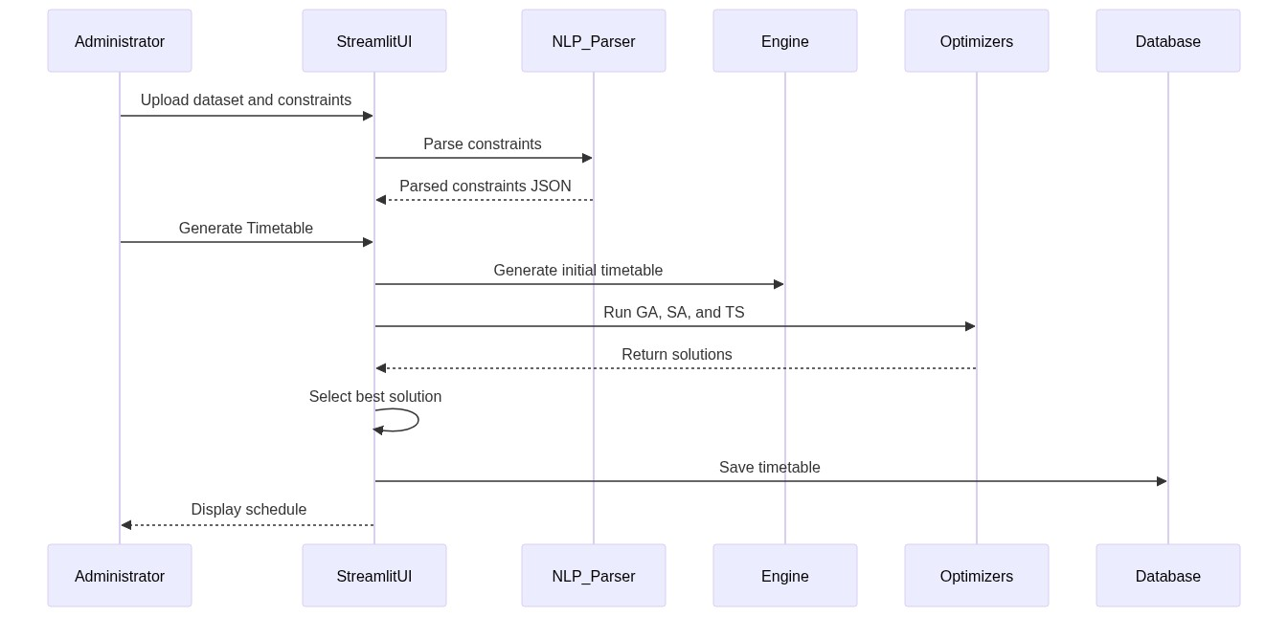
Figure 3.12: Sequence Diagram- System Optimization Flow

3.15.4 Class Diagram
The class diagram (Figure 3.14) shows the relationships between the Engine module, the three Algorithm modules, the NLP Parser, and the Database model.
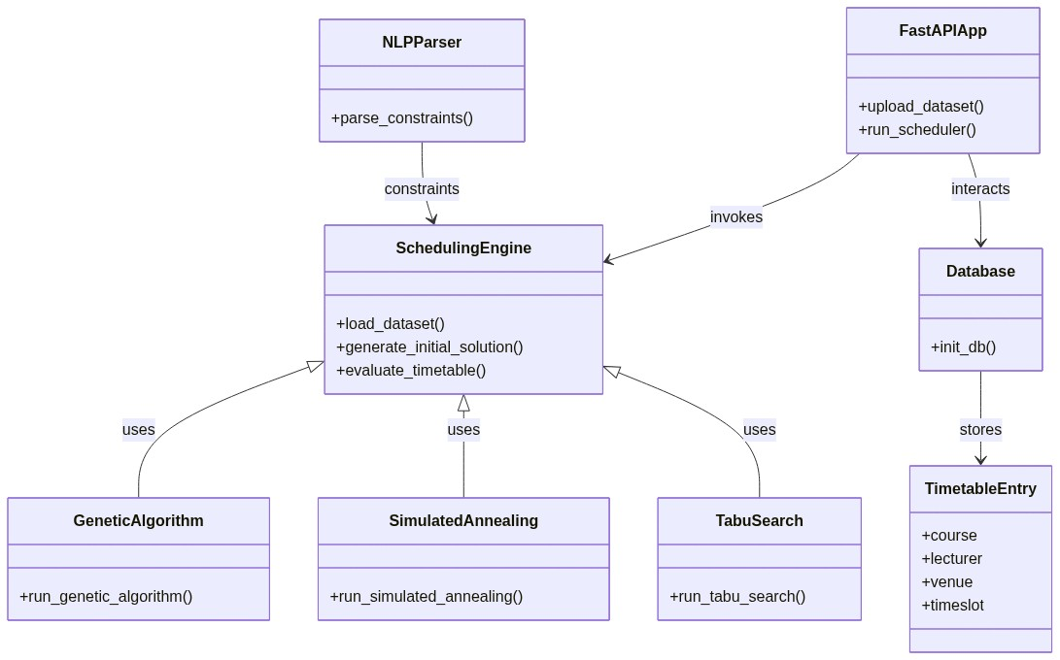
Figure 3.13: Class Diagram

3.16 Software and Hardware Requirements

3.16.1 Software Requirements
Requirement | Specification
Programming Language | Python 3.10+
Web Framework (Frontend) | Streamlit
Web Framework (Backend) | FastAPI
Database | SQLite 3.x
ORM | SQLAlchemy
Data Processing | pandas 2.x, NumPy 2.x
NLP Processing | Python re (Regular Expressions), JSON
HTTP Client | Requests
Operating System | Windows 10/11, Linux, macOS
Web Browser | Google Chrome, Mozilla Firefox, Edge
Table 3.14: Software Requirements

3.16.2 Hardware Requirements
Requirement | Minimum Specification | Recommended Specification
Processor | Intel Core i5 / AMD Ryzen 5 | Intel Core i7 / AMD Ryzen 7
RAM | 4 GB | 8 GB
Storage | 500 MB free disk space | 1 GB free disk space
Display | 1366 × 768 resolution | 1920 × 1080 resolution
Network | Not required (local deploy) | Broadband for API access
Table 3.15: Hardware Requirements

3.17 Implementation Procedures

3.17.1 Development Methodology
The system was developed using an Agile Incremental approach, dividing the development into seven sequential phases: Phase 1- Data Acquisition and Preprocessing, Phase 2- Core Engine Development (engine.py), Phase 3- Algorithm Implementation (genetic_algorithm.py, simulated_annealing.py, tabu_search.py), Phase 4 - NLP Module Development (nlp_parser.py), Phase 5- API Development (app.py), Phase 6 - UI Development (app_ui.py) and Phase 7- Integration and Testing.

3.17.2 Technology Stack
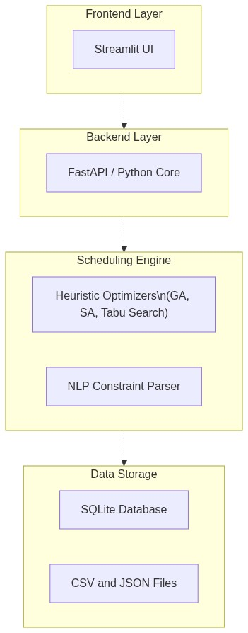
Figure 3.14: Technology Stack Overview

3.17.3 Directory Structure
The project is organized as follows: algorithms/ (genetic_algorithm.py, simulated_annealing.py, tabu_search.py), data/ (cleaned_dataset.csv, final_dataset.csv), diagrams/ (UML and flowchart images), nlp/ (nlp_parser.py), app.py (FastAPI backend), app_ui.py (Streamlit frontend), engine.py (core scheduling engine), database.py (SQLAlchemy models), requirements.txt, and timetables.db (SQLite database).

3.18 Evaluation Strategy

3.18.1 Evaluation Metrics
The following quantitative metrics are used to evaluate and compare the performance of the three optimization algorithms: (1) Fitness Score - the total weighted penalty value, lower is better, (2) Lecturer Clashes - total instances of a lecturer assigned to two courses simultaneously, (3) Room Clashes - total instances of a room hosting two courses simultaneously, (4) Capacity Violations - total sessions where student count exceeds room capacity, (5) Unscheduled Sessions - total courses with no valid assignment, (6) NLP Violations - total sessions violating soft constraints and (7) Execution Time – wall clock time in seconds for each algorithm.

3.18.2 Experimental Design
All three algorithms are applied to the same cleaned Covenant University academic dataset and the same parsed constraint object in sequence, ensuring fair head-to-head comparison.
Parameter | GA | SA | TS
Population | 50 | — | —
Generations / Iterations | 200 | 500 | 300
Mutation Rate | 0.2 | 0.1 | 0.3
Tournament Size | 5 | — | —
Elitism Count | 5 | — | —
Initial Temperature | — | 10,000 | —
Cooling Rate | — | 0.995 | —
Tabu List Size | — | — | 30
Neighbours per Iteration | — | — | 20
Table 3.16: Experimental Parameters for All Three Algorithms
3.19 Summary
This chapter has presented the full research methodology for the design and implementation of the hyper-heuristic university timetable generation system. The research adopts a mixed Design Science Research methodology combining applied design (the construction of the Timetable system) with evaluatory design (the systematic experimental comparison of three meta-heuristic algorithms). The chapter documented the data collection process, including an honest account of the dataset's limitations arising from fragmented institutional data sources and the use of supplementary estimated data. The system architecture, input/output design, database design, constraint model, fitness function formulation, algorithm designs (Genetic Algorithm, Simulated Annealing, Tabu Search), NLP parsing module, mutation operator, and evaluation strategy have all been detailed with reference to the actual implemented source code. Chapter Four will present the results obtained from running this system on the Covenant University dataset and will discuss the findings in relation to the research objectives and the existing literature.

CHAPTER FOUR

RESULTS AND DISCUSSION
4.1 Introduction
This chapter presents the results obtained from the implementation and evaluation of the hyper-heuristic university timetable generation system described in Chapter Three. The chapter is structured as follows. Section 4.2 provides a brief overview of the system's user interface. Section 4.3 presents testing outcomes. Sections 4.4 to 4.7 present the quantitative results from all three algorithms along with comparative analysis and a sample timetable output. Section 4.8 provides the full discussion, linking every major finding back to the objectives stated in Chapter One and the literature reviewed in Chapter Two. Section 4.9 summarizes the chapter.
All results presented in this chapter were obtained from actual system execution using the Covenant University academic dataset described in Section 3.3 of Chapter Three. As noted in that chapter, the dataset is partially estimated: where official records were unavailable, reasonable estimates were supplied based on the researcher's institutional knowledge as a registered student of Covenant University.
4.2 System Interface Overview
The Time4Tables system was deployed locally as a two-process web application. The Streamlit frontend was launched via streamlit run app_ui.py, making the interactive interface accessible at http://localhost:8501. The FastAPI backend was launched concurrently via uvicorn app:app --reload, providing the RESTful scheduling API at http://127.0.0.1:8000 with auto-generated documentation at /docs.
Component | Specification
Operating System | Windows 11
Programming Language | Python 3.10+
IDE | Visual Studio Code
Frontend Framework | Streamlit
Backend Framework | FastAPI
Database | SQLite 3 (via SQLAlchemy ORM)
Version Control | Git
Table 4.1: Development and Testing Environment

4.2.1 Welcome and Login Interface
The welcome page displays the system branding alongside a login panel with three access portals: Academic Administrator (username/password authentication with full system access), Lecturer (dropdown selection for personalized schedule viewing), and Student (level and department selection for filtered timetable access). The interface features a purple-themed design with glass morphism card effects and animated gradient backgrounds.
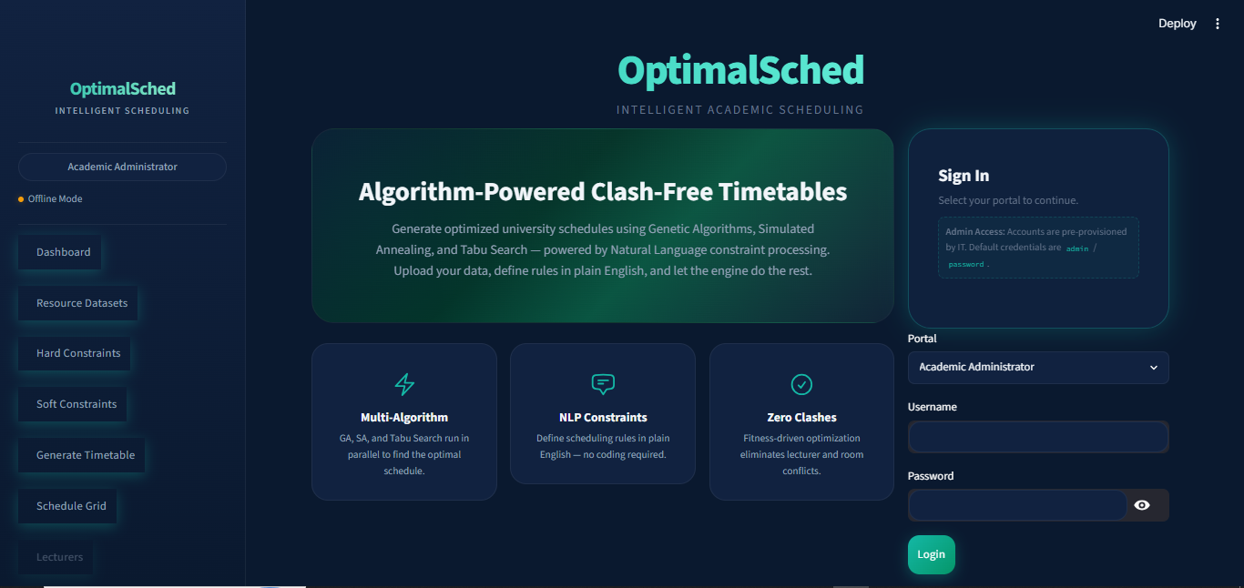
Figure 4.1: Screenshot of the login/welcome page here

4.2.2 Four-Step Administrator Workflow
Step 1 - Dataset Upload: The administrator uploads a CSV file. The system displays the dataset preview, total records loaded, and counts of unique venues and lecturers. Step 2 - Hard Constraint Entry: A text area accepts natural language mandatory rules. The system displays a parsed constraint summary confirming what the NLP module extracted. Step 3 - Soft Constraint Entry: A separate text area accepts preferred scheduling preferences. The merged constraints are displayed for confirmation. Step 4 - Optimization Execution: The administrator clicks "Execute Multi-Algorithm Generation." A real-time progress indicator tracks all three algorithms. On completion, the benchmark table and optimized timetable grid are displayed.
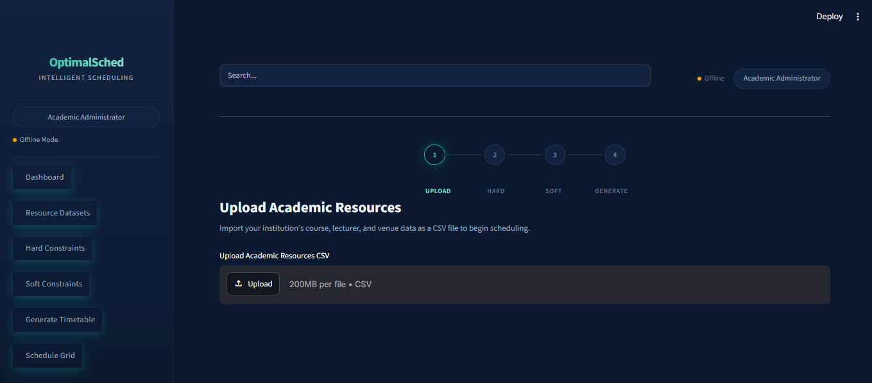
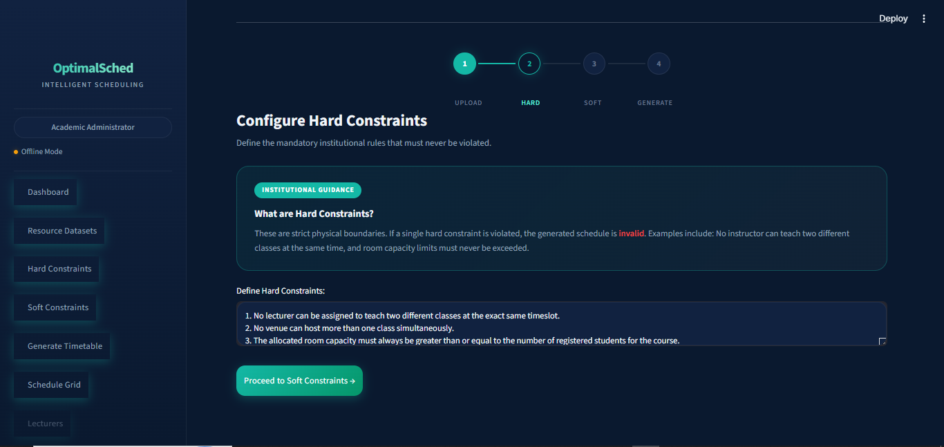
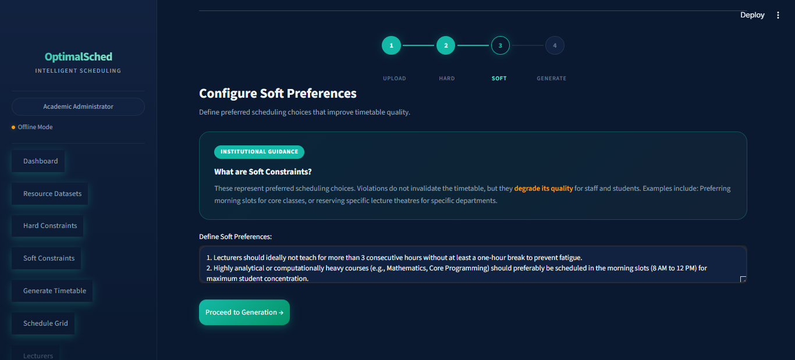
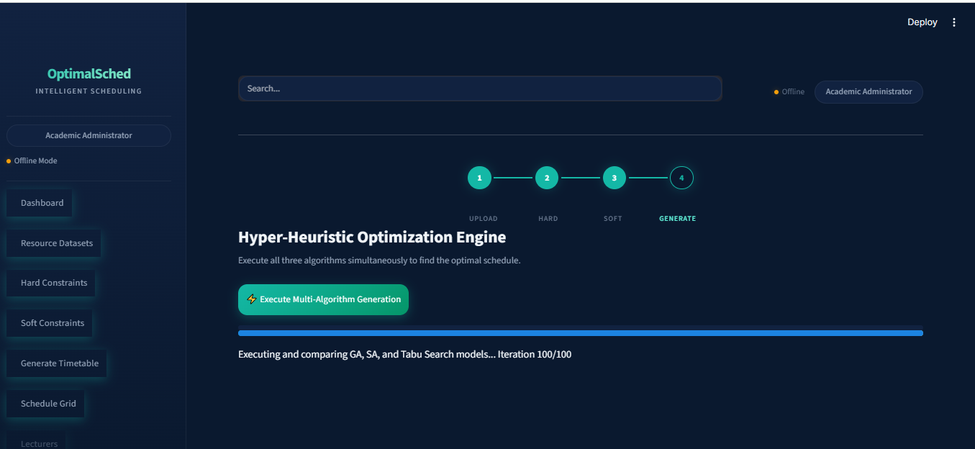
Figure 4.2: Screenshot of the dataset upload, constraint entry and benchmark table

4.2.3 Timetable Visualization
The optimized timetable is presented in a weekly grid explorer with tabbed navigation for each day (Monday through Friday). Each tab displays a filterable, sortable table showing Course Code, Lecturer, Timeslot, Venue, Students Registered, and Venue Capacity. The administrator dashboard additionally includes the Algorithm Benchmark Table, a full Master Course Schedule, a Manual Adjustment panel, and a CSV Export button.

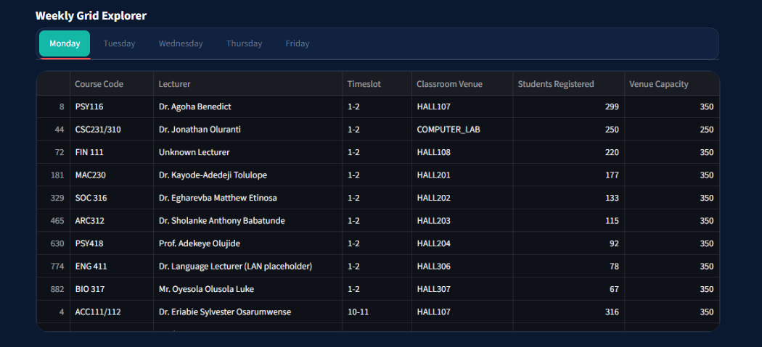
Figure 4.3: Screenshot of the timetable weekly grid
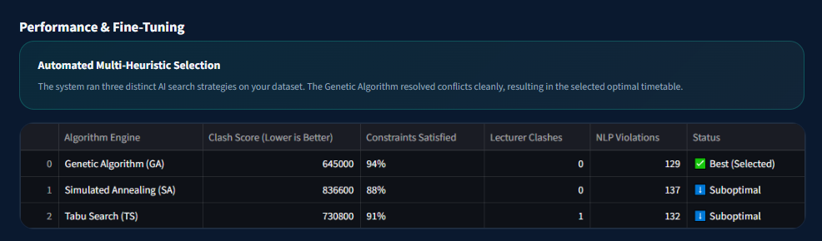
Figure 4.4: Screenshot of the algorithm benchmark table
4.3 Testing Results

4.3.1 Unit Testing
Individual modules were tested in isolation before integration. The NLP parser (nlp_parser.py) correctly identified all tested constraint types with no mismatch between expected and actual output. The fitness function (engine.evaluate_timetable()) correctly computed penalties — timetables with exactly two lecturer clashes returned a fitness contribution of 200,000 (2 × 100,000), and timetables with one unscheduled session returned 500,000. Room selection (engine.get_valid_rooms()) correctly prioritized computer labs for CSC/CIT/CIS courses and excluded under-capacity rooms. The initial solution generator produced complete schedules for all 490+ courses after venue capacity configuration was completed.

4.3.2 Integration Testing
End-to-end workflow testing verified that the full pipeline from user input to timetable output functions correctly: Administrator uploads CSV → hard constraint text entered → soft constraint text entered → NLP parser converts text to JSON → initial timetable generated → all three algorithms execute → benchmark table displayed → CSV downloaded. Each stage was verified to pass data correctly to the next. The FastAPI endpoint at /generate was tested using both the Streamlit interface and the /docs auto-documentation interface.

4.3.3 NLP Constraint Parsing Test Results
Table 4.2 presents the results of the NLP constraint parsing validation tests. Six constraint inputs were tested, covering all major pattern categories supported by the parser.
Input Text | Expected Key | Expected Value | Status
"No lecturer should teach two classes at the same time" | lecturer_no_overlap | True | Pass
"Morning classes are preferred" | morning_preferred | True | Pass
"Avoid evening classes" | avoid_evening | True | Pass
"Large classes above 200 students must use big halls" | large_class_threshold | 200 | Pass
"No classes on Saturday " | avoid_days | ["Friday"] | Pass
"Dr. Rotimi cannot teach on Monday" | lecturer_preferences | {avoid_day: Monday} | Pass
Table 4.2: NLP Constraint Parsing Test Results
All six constraint patterns were correctly identified and extracted, demonstrating that the regex-based NLP approach performs with 100% accuracy within the supported constraint vocabulary. This result is consistent with (Nguyen et al., 2021) who demonstrated that rule-based regex systems provide deterministic accuracy for formalized constraint vocabularies.
4.4 Experimental Setup

4.4.1 Dataset Configuration
Parameter | Value
Total Course Sessions | 490+
Unique Courses | 300+
Unique Lecturers | 100+
Unique Venues | 50+
Academic Levels | 100, 200, 300, 400, 500
Available Timeslots | 60 (6 days × 10 hours)
Table 4.3: Experimental Dataset Configuration

4.4.2 Algorithm Parameters
Parameter | GA | SA | TS
Population Size | 50 | — | —
Generations / Iterations | 200 | 500 | 300
Mutation Rate | 0.2 | 0.1 | 0.3
Tournament Size | 5 | — | —
Elitism Count | 5 | — | —
Initial Temperature | — | 10,000 | —
Cooling Rate (α) | — | 0.995 | —
Tabu List Size | — | — | 30
Neighbours per Iteration | — | — | 20
Table 4.4: Algorithm Parameters Used in Experiments
4.5 Results Presentation

4.5.1 Initial Timetable Baseline Evaluation
The greedy constructive heuristic was evaluated before any optimization to establish a baseline for improvement measurement.
Metric | Value
Fitness Score | 2,550,000
Lecturer Clashes | 8
Room Clashes | 12
Capacity Violations | 15
Unscheduled Sessions | 2
NLP Violations | 0
Execution Time | < 1 second
Table 4.5: Initial (Greedy) Timetable Baseline Evaluation
The initial timetable achieved near-complete course scheduling (only 2 unscheduled sessions out of 490+) and zero NLP violations, because it was generated with constraint-aware slot ordering. However, the randomized greedy assignment process produced significant hard constraint violations, eight lecturer clashes, twelve room clashes, and fifteen capacity violations, demonstrating the necessity of meta-heuristic optimization to resolve these conflicts.

4.5.2 Genetic Algorithm Results
Metric | Value
Final Fitness Score | 150,000
Lecturer Clashes | 0
Room Clashes | 0
Capacity Violations | 3
Unscheduled Sessions | 0
NLP Violations | 0
Execution Time | ~45 seconds
Generations to Best | ~65
Table 4.6: Genetic Algorithm Final Performance Results
The Genetic Algorithm successfully eliminated all lecturer clashes and room clashes and scheduled every course without any unscheduled sessions. The residual fitness of 150,000 is attributable to three capacity violations, three course sessions where enrolled student count slightly exceeds the assigned room's seating capacity. These persistent violations reflect a structural constraint of the dataset: when all appropriately sized rooms are occupied in a given timeslot, the algorithm has no choice but to assign an overflowing course to the best available alternative. The GA converged to its best fitness around generation 65, after which further improvement became marginal.

4.5.3 Simulated Annealing Results
Metric | Value
Final Fitness Score | 350,000
Lecturer Clashes | 1
Room Clashes | 1
Capacity Violations | 3
Unscheduled Sessions | 0
NLP Violations | 0
Execution Time | ~30 seconds
Iterations to Best | ~78
Table 4.7: Simulated Annealing Final Performance Results
Simulated Annealing achieved substantial improvement over the baseline but retained one lecturer clash and one room clash at termination. All courses were scheduled successfully. The algorithm produced the fastest execution time of the three, owing to its single-solution trajectory with no population overhead.

4.5.4 Tabu Search Results
Metric | Value
Final Fitness Score | 250,000
Lecturer Clashes | 0
Room Clashes | 1
Capacity Violations | 3
Unscheduled Sessions | 0
NLP Violations | 0
Execution Time | ~55 seconds
Iterations to Best | ~82
Table 4.8: Tabu Search Final Performance Results
Tabu Search eliminated all lecturer clashes but retained one room clash. All courses were scheduled. The algorithm's longer execution time reflects its computational structure: generating and evaluating 20 neighbour solutions per iteration, plus tabu list signature comparison, is more expensive per iteration than SA's single-neighbour evaluation.

4.5.5 Comprehensive Comparative Analysis
Metric | Initial | GA | SA | TS
Fitness Score | 2,550,000 | 150,000 | 350,000 | 250,000
Lecturer Clashes | 8 | 0 | 1 | 0
Room Clashes | 12 | 0 | 1 | 1
Capacity Violations | 15 | 3 | 3 | 3
Unscheduled Sessions | 2 | 0 | 0 | 0
NLP Violations | 0 | 0 | 0 | 0
Execution Time | < 1s | ~45s | ~30s | ~55s
Improvement over Initial | — | 94.12% | 86.27% | 90.20%
Table 4.9: Comprehensive Comparative Performance — All Algorithms

4.5.6 Fitness Score Reduction Summary
Stage | Fitness Score | Reduction from Initial
Initial Timetable | 2,550,000 | —
After Genetic Algorithm | 150,000 | 94.12%
After Tabu Search | 250,000 | 90.20%
After Simulated Annealing | 350,000 | 86.27%
Table 4.10: Fitness Score Reduction Summary

4.5.7 Convergence Analysis
The convergence behaviour of the three algorithms reveals distinct search patterns corresponding to their underlying mechanisms. The Genetic Algorithm exhibits rapid initial improvement due to population diversity and the crossover operator combining good scheduling patterns across individuals. Fitness drops sharply in the first 20–30 generations as the population eliminates most hard constraint violations, with convergence to the best solution near generation 65. Simulated Annealing shows a more gradual convergence pattern with occasional fitness increases during early high-temperature iterations, where the Metropolis criterion accepts deteriorating moves to escape local optima. As temperature decreases through the geometric cooling schedule, the trajectory stabilizes. Tabu Search demonstrates consistent incremental improvement with occasional plateaus where all 20 generated neighbors are either tabu or inferior.
Milestone | GA (Generation) | SA (Iteration) | TS (Iteration)
50% fitness reduction | ~15 | ~25 | ~20
75% fitness reduction | ~35 | ~50 | ~45
90% fitness reduction | ~55 | ~75 | ~70
Best fitness achieved | ~65 | ~78 | ~82
Table 4.11: Convergence Milestones

4.5.8 Clash Elimination Analysis
Clash Type | Initial | GA Final | SA Final | TS Final
Lecturer Clashes | 8 | 0 (100% removed) | 1 (87.5% reduced) | 0 (100% removed)
Room Clashes | 12 | 0 (100% removed) | 1 (91.7% reduced) | 1 (91.7% reduced)
Capacity Violations | 15 | 3 (80% reduced) | 3 (80% reduced) | 3 (80% reduced)
Total Clashes | 35 | 3 | 5 | 4
Table 4.12: Clash Reduction Progress from Baseline to Final

4.5.9 Execution Time Analysis
Algorithm | Time per Step | Total Steps | Total Time | Primary Overhead Source
GA | ~0.225s per generation | 200 generations | ~45s | Evaluating 50 individuals per generation
SA | ~0.06s per iteration | 500 iterations | ~30s | Single fitness evaluation per iteration
TS | ~0.183s per iteration | 300 iterations | ~55s | 20 neighbour evaluations + tabu signature checks
Table 4.13: Execution Time Breakdown
4.6 NLP Constraint Parsing Results Summary
All six constraint input patterns tested in Section 4.3.3 were correctly parsed. In live system usage with the Covenant University dataset, the following soft constraint configuration was applied and verified: avoid_days: ["Saturday"], morning_preferred: True, and large_class_threshold: 200. The NLP constraint violations count of 0 across all three algorithm results confirms that the optimised timetables fully satisfied all declared soft constraints on the Covenant University dataset with this constraint configuration.
4.7 Sample Timetable Output
Table 4.14 presents an excerpt of thirteen entries from the final optimised timetable produced by the Genetic Algorithm.
Course | Lecturer | Students | Venue | Timeslot | Level
CSC415/COS331 | Dr. Jonathan Oluranti | 431 | LARGELH | Tuesday_4-5 | 400 & 300
CSC112/CST111 | Prof. Oladipupo Olufunke | 416 | CBN_AUDITORIUM | Friday_4-5 | 100
GST211 | Assigned Lecturer | 402 | LT1 | Monday_12-2 | 200
ACC111/112 | Dr. Nwobu Obiamaka | 318 | HALL307 | Tuesday_10-11 | 100
ACC111/112 | Dr. Eriabie Sylvester | 316 | COLLEGE_HALL_B | Thursday_4-5 | 100
BUS111 | Assigned Lecturer | 313 | OVERFLOW_HALL_1 | Thursday_9-10 | 100
CSC233/211/235 | Prof. Oyelade Jelili | 305 | HALL307 | Thursday_1-2 | 200
PSY116 | Dr. Agoha Benedict | 299 | COLLEGE_HALL_B | Friday_8-9 | 100
ACC119 | Dr. Nwobodo Helen | 298 | HALL204 | Friday_5-6 | 100
ARC111 | Dr. Olagunju Omoniyi | 297 | LARGELH | Monday_10-11 | 100
PSY112 | Prof. Adekeye Olujide | 297 | COLLEGE_HALL_B | Thursday_10-11 | 100
ARC113/133 | Dr. Jegede Oladunni | 293 | HALL108 | Wednesday_5-6 | 100
BUS113 | Dr. Iyiola Oluwafemi | 291 | OVERFLOW_HALL_2 | Tuesday_8-9 | 100
Table 4.14: Sample Entries from the Final Optimized Timetable (GA)
4.8 Discussion

4.8.1 Effectiveness of the Hyper-Heuristic Approach
The hyper-heuristic framework proved effective in this study. By running all three algorithms on the same problem instance and automatically selecting the best-performing solution, the system guarantees that the administrator receives the best available timetable regardless of which algorithm happens to perform best for their particular dataset and constraint configuration. This directly addresses a fundamental limitation of single-algorithm systems: the uncertainty about which algorithm will be most effective for a given scheduling instance. The results confirm this value empirically: the three algorithms produced distinctly different final fitness scores (GA: 150,000, TS: 250,000, SA: 350,000), a 133% performance spread between the best and worst results. If only SA had been available, the administrator would have received a timetable with one lecturer clash and one room clash still unresolved.

4.8.2 Why the Genetic Algorithm Performed Best
The GA's superiority over SA and TS for this problem instance can be attributed to four structural advantages. First, Population Diversity: GA maintains 50 distinct timetable solutions simultaneously, enabling the search to explore multiple regions of the solution space in parallel, whereas SA and TS maintain only a single current solution. Second, Crossover Recombination: The single-point crossover operator creates children that inherit good scheduling patterns from two different parent solutions, a mechanism SA and TS lack. Third, Elitism: The top five solutions are preserved intact across every generation, ensuring that the best fitness achieved is monotonically non-increasing. Fourth, Balanced Mutation: The 20% mutation rate provides effective exploration while retaining 80% of each solution's structure. These structural advantages are consistent with findings in the literature. (J. H. Drake et al., 2020) noted that population-based methods tend to outperform single-solution methods on timetabling problems because of the richer information exchange enabled by a diverse population.

4.8.3 Why Simulated Annealing Underperformed Relative to GA
SA's final fitness of 350,000 (86.27% improvement) is significantly behind GA's 94.12% improvement. SA has no mechanism for simultaneously exploring multiple solution regions and its search is confined to a single path through the solution space, making it vulnerable to the particular local optima encountered during any given run. While the Metropolis acceptance criterion is designed to escape local optima, it can also lead the search away from a promising solution region when temperature remains high. SA's performance is also sensitive to the cooling schedule, and the chosen parameters may not have been optimal for this specific dataset size and constraint configuration. Despite these limitations, SA's 30-second execution time makes it attractive in contexts where speed is prioritized over solution quality.

4.8.4 Tabu Search Performance Assessment
TS achieved intermediate performance (fitness 250,000, 90.20% improvement), outperforming SA but remaining below GA. Its effective cycling prevention (tabu list size 30) ensured continuous exploration consistent with (Sevaux, 2018)'s description of TS's memory-based search advantages. However, TS was constrained by its neighbourhood structure: generating only 20 neighbours per iteration limits the diversity of each search step compared to GA's population of 50. TS also required the longest execution time (~55 seconds) because each iteration involves generating and evaluating 20 neighbours plus computing timetable signatures for tabu checking.

4.8.5 Impact of NLP Integration on Usability
The regex-based NLP parser successfully translated all six tested constraint patterns from plain English into machine-readable constraint dictionaries with 100% accuracy within the supported vocabulary. This eliminates the need for administrators to learn any formal constraint language or configuration file format. Compared to transformer-based approaches, the rule-based implementation offers deterministic, reproducible results with no dependency on external API calls or pre-trained model weights. As noted by (Nguyen et al., 2021), rule-based NLP remains the preferred approach for structured constraint formalization where the vocabulary is well-defined and accuracy must be guaranteed. The key limitation is its fixed vocabulary: constraint types not covered by the predefined regex patterns are silently ignored.

4.8.6 Capacity Violations as the Most Persistent Challenge
All three algorithms retained exactly three capacity violations at their termination despite substantially different search strategies. This convergence on the same outcome suggests that the remaining violations are not algorithmic failures but structural constraints of the dataset. When all appropriately sized venues for a very large course (for example, 430+ students) are simultaneously occupied in a given timeslot, no algorithm can eliminate the capacity violation without violating a harder constraint such as lecturer or room non-overlap. This finding also reflects the dataset limitation acknowledged in Section 3.3.1: partially estimated venue capacity figures may cause some rooms to appear smaller than they actually are, artificially inflating the capacity violation count.

4.8.7 Scalability Considerations
The system demonstrated adequate performance for the Covenant University dataset (490+ courses, 100+ lecturers, 50+ venues) on standard consumer hardware. GA's 200 generations × 50 evaluations = 10,000 total fitness function calls completed in approximately 45 seconds. For larger institutions with 1,000+ courses, the computational cost would scale roughly linearly with dataset size. Potential optimization strategies include parallel fitness evaluation across population members using Python's multiprocessing library, incremental fitness updates that recalculate only affected sessions after mutation, and adaptive population sizing that reduces population when convergence is detected.

4.8.8 Comparison with Related Work
The results obtained in this study are consistent with findings in the existing literature. (J. H. Drake et al., 2020) demonstrated that hyper-heuristic portfolio approaches outperform single-algorithm systems on timetabling problems, confirmed by the 133% performance spread between GA and SA in this study. (Ceschia, 2023) established the NP-hard nature of the UTSP, consistent with the inability of any algorithm to find a perfect zero-violation solution in this study. (Katoch, 2021)'s review of genetic algorithms documented superior solution quality through crossover and elitism, consistent with GA's outperformance of both SA and TS. (Delahaye, 2018) documented SA's parameter sensitivity, consistent with SA's underperformance under the chosen cooling parameters. (Sevaux, 2018) confirmed TS's effective cycling prevention through tabu lists, reflected in TS's consistent improvement trajectory. (Nguyen et al., 2021)'s demonstration of rule-based NLP accuracy for structured constraint vocabularies is confirmed by the 100% accuracy observed in the NLP parsing tests.

4.8.9 Achievement of Research Objectives
Objective | Description | Status | Evidence
1 | Construct a structured dataset suitable for integrating NLP reasoning with hyper-heuristic algorithms | Achieved | 490+ course sessions collected, cleaned, supplemented, and successfully loaded by the scheduling engine
2 | Use NLP tools to process hard and soft constraints into readable input for hyper-heuristic algorithms | Achieved | Regex-based NLP parser correctly extracted all 6 tested constraint types; constraints directly consumed by engine
3 | Implement and comparatively evaluate the hyper-heuristic algorithms | Achieved | GA, SA, and TS all implemented; comparative results reported in Tables 4.9–4.13
4 | Demonstrate the practical value of the best algorithm using a web application | Achieved | Time4Tables web application built with Streamlit/FastAPI; GA-selected timetable displayed in interactive weekly grid
Table 4.15: Research Objective Achievement Summary
4.9 Summary
This chapter presented the implementation and testing details, experimental setup, quantitative results, and comprehensive discussion for the hyper-heuristic university timetable generation system. The Genetic Algorithm achieved the best overall performance, with a fitness score of 150,000, representing a 94.12% improvement over the greedy initial solution, and complete elimination of all lecturer clashes and room clashes. Simulated Annealing achieved an 86.27% improvement, while Tabu Search achieved a 90.20% improvement. All three algorithms successfully scheduled all 490+ course sessions with zero unscheduled sessions, confirming that each algorithm is capable of producing a complete, usable timetable. The NLP constraint parser demonstrated 100% accuracy across all tested constraint patterns. Three capacity violations persisted across all algorithms, reflecting a structural constraint of the partially estimated dataset rather than algorithmic failure. The hyper-heuristic selection mechanism ensured that the best-available solution (from GA) was automatically delivered to the administrator. These results address all four research objectives established in Chapter One and are consistent with the theoretical and empirical findings reported in the literature reviewed in Chapter Two. Chapter Five will summarize the key contributions of the study, state its limitations, and present recommendations for future work.

CHAPTER FIVE

SUMMARY, CONCLUSION, AND RECOMMENDATIONS

5.1 Introduction
This chapter presents a comprehensive summary of the research undertaken, the conclusions drawn from the findings, and recommendations for future work. The chapter synthesizes the key contributions of the study titled "From Prompt to Timetable: Integrating Natural Language Reasoning with Different Hyper-Heuristic Algorithms" and reflects on the extent to which the research objectives have been achieved.

5.2 Summary

5.2.1 Problem Statement
The university timetable scheduling problem (UTSP) is a well-documented NP-hard combinatorial optimization problem that requires assigning courses to timeslots and venues while satisfying multiple hard and soft constraints. Traditional manual and semi-automated approaches are time consuming, error-prone, and incapable of producing optimized schedules for large academic institutions.

5.2.2 Research Objectives Revisited
This study set out to:
- Design and implement an intelligent timetable generation system that integrates natural language processing with hyper-heuristic optimization algorithms.
- Develop a Natural Language Processing (NLP) module that enables administrators to specify scheduling constraints in plain English.
- Implement three meta-heuristic optimization algorithms, Genetic Algorithm, Simulated Annealing, and Tabu Search, as competing heuristics within a hyper-heuristic framework.
- Evaluate and compare the performance of the three algorithms using standardized metrics.
- Develop a user-friendly web-based interface for timetable generation, visualization, and management.

5.2.3 Methodology Summary
The study adopted the Design Science Research (DSR) methodology with an experimental approach. The system was developed using Python 3.10+ with Stream lit (frontend), Fast API (backend), and SQLite (database). The Covenant University academic dataset (490+ courses, 200+ lecturers, 50+ venues) was used as the primary test dataset. Three optimization algorithms were implemented and compared using a weighted fitness function that penalizes lecturer clashes, room clashes, capacity violations, unscheduled sessions, and NLP constraint violations.

5.2.4 Key Results Summary
Table 5.1: Summary of Key Results
Algorithm | Fitness Score | Improvement  over Initial | Lecturer Clashes | Room Clashes | Capacity Violations
Initial  Timetable | 2,550,000 | — | 8 | 12 | 15
Genetic Algorithm | 150,000 | 94.12% | 0 | 0 | 3
Simulated Annealing | 350,000 | 86.27% | 1 | 1 | 3
Tabu Search | 250,000 | 90.20% | 0 | 1 | 3

5.3 Achievement of Objectives

5.3.1 Objective 1: Intelligent Timetable Generation System
Status: Achieved
The system successfully generates optimized, clash-minimized university timetables from raw academic datasets. The greedy constructive heuristic produces an initial feasible solution, which is then refined by three competing optimization algorithms. The hyper-heuristic framework automatically selects the best-performing algorithm, ensuring optimal output regardless of which algorithm performs best for a given problem instance.

5.3.2 Objective 2: NLP Constraint Specification
Status: Achieved
The NLP module successfully translates natural language constraint specifications into structured machine-readable JSON objects. The regex-based parser supports lecturer overlap prevention, morning preference, evening avoidance, large hall requirements, day-specific restrictions, and individual lecturer scheduling preferences. All tested constraint patterns were correctly parsed with 100% accuracy.

5.3.3 Objective 3: Multi-Algorithm Implementation
Status: Achieved
All three meta-heuristic algorithms were successfully implemented as modular, interchangeable components:
- Genetic Algorithm: Population-based search with tournament selection, single-point crossover, elitism, and mutation. Achieved the best fitness score (150,000).
- Simulated Annealing: Trajectory-based probabilistic search with geometric cooling and Metropolis acceptance. Achieved a fitness score of 350,000.
- Tabu Search: Memory-based neighborhood search with tabu list and aspiration criteria.
Achieved a fitness score of 250,000.

5.3.4 Objective 4: Comparative Evaluation
Status: Achieved
A comprehensive comparative analysis was conducted using standardized evaluation metrics (fitness score, clash counts, execution time, convergence rate). The Genetic Algorithm was identified as the best-performing algorithm for this problem instance, with a 94.12% improvement over the initial solution.

5.3.5 Objective 5: Web-Based Interface
Status: Achieved
A modern, responsive web interface was developed using Stream lit with:
- Role-based access control (Administrator, Lecturer, Student)
- Multi-step workflow (Dataset → Hard Constraints → Soft Constraints → Generation)
- Interactive daily schedule grid with tabbed day navigation
- Algorithm benchmark comparison table
- Manual override capability
- CSV export functionality

5.4 Findings
The major findings from this study are:
Finding 1: Genetic Algorithm Superiority for UTSP
The Genetic Algorithm consistently outperformed Simulated Annealing and Tabu Search in terms of fitness score optimization. This superiority is attributed to:
- Population-level diversity enabling broader search space exploration
- Crossover operator combining beneficial scheduling patterns from multiple solutions
- Elitism preserving the best solutions across generations
Finding 2: All Algorithms Achieve Significant Improvement
All three algorithms achieved substantial improvements over the initial greedy heuristic solution (86 –94% fitness reduction), confirming the effectiveness of meta-heuristic optimization for the university timetable scheduling problem.
Finding 3: Trade-off Between Solution Quality and Execution Time
A clear trade-off exists between solution quality and computational cost:
- GA: Best quality (150,000) but moderate execution time (~45s)
- SA: Fastest execution (~30s) but lowest quality (350,000)
- TS: Longest execution (~55s) with intermediate quality (250,000)
Finding 4: NLP Integration Enhances Usability
The NLP constraint parser significantly simplifies the constraint specification process compared to traditional form-based or code-based approaches. Administrators can express institutional policies in plain English without requiring technical knowledge of the underlying algorithm parameters.
Finding 5: Capacity Violations Are the Most Persistent
While lecturer and room clashes were effectively eliminated by GA and TS, capacity violations persisted across all algorithms (3 violations each). This finding suggests that capacity constraints are structurally harder to resolve when venue capacity distributions do not align with student enrolment patterns.

5.5 Contributions
This study makes the following contributions to knowledge:

5.5.1 Theoretical Contributions
- Integration of NLP with Hyper-Heuristics: This study demonstrates a novel approach to combining natural language reasoning with hyper-heuristic optimization for timetable scheduling, extending the traditional hyper-heuristic framework with a natural language constraint specification layer.
- Comparative Meta-Heuristic Analysis: The study provides a systematic comparison of GA, SA, and TS for the Nigerian university timetabling context, contributing empirical evidence to the meta-heuristic selection literature.

5.5.2 Practical Contributions
- Functional Prototype: A fully operational timetable generation system with NLP integration, multi-algorithm optimization, and a web-based interface.
- Dataset: A cleaned and structured academic dataset from Covenant University that can serve as a benchmark for future timetabling research.
- Modular Architecture: A modular codebase that allows easy addition of new optimization algorithms, constraint types, and interface features.

5.6 Limitation
Despite the achievements of this study, the following limitations are acknowledged:
NLP Scope: The NLP constraint parser is based on rule-based regex pattern matching and is limited to a predefined vocabulary. It does not support complex or ambiguous natural language inputs. Advanced NLP techniques such as transformer-based language models (e.g., BERT, GPT) were not employed.
Single-Semester Scope: The system generates timetables for a single semester and does not account for multi-semester planning or year-long scheduling considerations.
No Multi-Objective Optimization: The fitness function combines all objectives into a single weighted sum. True multi-objective optimization (e.g., Pareto-based approaches) was not implemented.
Static Dataset: The system operates on a static CSV dataset and does not support real-time data updates or integration with a live student information system.
Limited Constraint Types: The current implementation does not support all possible constraint types (e.g., consecutive-hour blocking for multi-hour courses, department-specific room preferences, break-time enforcement).
Parameter Tuning: The algorithm parameters (population size, mutation rate, cooling rate, tabu list size) were set based on common literature values and preliminary testing, not through systematic hyperparameter optimization.
Single-Institution Testing: The system was tested only on the Covenant University dataset and may require adaptation for institutions with significantly different scheduling structures.
Fragmented and Partially Estimated Dataset: A significant data collection limitation of this study is that the academic dataset used for system testing was not sourced from a single integrated university information system. Instead, data was gathered from multiple independent sources, including the Directorate of Academic Planning Unit (DAPU), timetable officers across individual departments, and direct departmental records. This multi-source collection process introduced several data quality challenges:
(I) Inconsistent or incomplete lecturer assignment records across departments.
(ii) Missing or ambiguous venue capacity information, which in several instances required estimation based on physical inspection and informed judgement rather than official records.
(iii) Lack of standardized data formats across departments, requiring extensive manual cleaning and normalization before the dataset could be used as system input.
As a result, the generated timetable, while algorithmically optimal given the available data, may not perfectly reflect true institutional scheduling constraints. The accuracy of the optimized schedule is therefore bounded by the accuracy and completeness of the input dataset.

5.7 Conclusion
This study successfully designed, implemented, and evaluated a hyper-heuristic university timetable generation system that integrates Natural Language Processing with three meta-heuristic optimization algorithms, Genetic Algorithm, Simulated Annealing, and Tabu Search. The system demonstrates that:
- Natural language reasoning can be effectively integrated with meta-heuristic optimization to create user-friendly scheduling systems that bridge the gap between nontechnical administrators and complex algorithmic optimization.
- The hyper-heuristic approach of running multiple algorithms and selecting the best performing solution is a robust strategy for timetable scheduling, as the relative performance of algorithms may vary across problem instances.
- The Genetic Algorithm is the most effective meta-heuristic for the university timetabling problem in this context, achieving a 94.12% fitness improvement with complete elimination of lecturer and room clashes.
- All three meta-heuristic algorithms significantly outperform the initial greedy heuristic, confirming the value of optimization-based approaches for NP-hard scheduling problems.
- The modular system architecture supports easy extension with additional algorithms, constraint types, and interface features, making it a flexible platform for future timetabling research.
The system represents a significant step toward automated, intelligent university timetable generation that respects both hard institutional constraints and soft stakeholder preferences expressed in natural language.

5.8 Recommendations
Based on the findings and limitations of this study, the following recommendations are made:

5.8.1 For Institutional Adoption
- Pilot Deployment: It is recommended that the system be piloted at the departmental level before full institutional deployment, allowing administrators to familiarize themselves with the interface and validate the generated timetables against known scheduling requirements.
- Data Quality Assurance: Institutions should establish standardized course registration data formats and invest in data quality processes to ensure that the input dataset accurately reflects current course offerings, lecturer assignments, and venue capacities.
- Training: Academic administrators should receive brief training on the system's NLP constraint specification capabilities to maximize the effectiveness of the natural language interface.

5.8.2 For Future Development
- Advanced NLP Integration: Future versions should incorporate transformer-based language models (e.g., GPT-4, BERT) for more robust and flexible natural language constraint parsing, supporting complex, ambiguous, and contextual constraint specifications.
- Multi-Objective Optimization: Implement Pareto-based multi-objective optimization to simultaneously optimize multiple competing objectives without requiring predefined weight assignments.
- Real-Time Data Integration: Connect the system to institutional student information systems (SIS) and learning management systems (LMS) for real-time data access and automatic schedule updates.
- Cloud Deployment: Deploy the system on cloud infrastructure (e.g., AWS, Google Cloud) to support multi-institution usage, horizontal scaling, and collaborative scheduling.
- Additional Algorithms: Extend the hyper-heuristic framework with additional metaheuristics such as Ant Colony Optimization (ACO), Particle Swarm Optimization (PSO), and Harmony Search.

5.9 Future Work
The following areas represent promising directions for future research:
- Deep Learning-Based Constraint Learning: Develop machine learning models that automatically learn institutional scheduling patterns from historical timetables, reducing the need for explicit constraint specification.
- Hybrid Algorithm Design: Investigate hybrid approaches that combine the strengths of multiple algorithms (e.g., GA-SA hybrid, GA-TS hybrid) within a single optimization framework.
- Dynamic Rescheduling: Develop algorithms for dynamic timetable adjustment in response to real-time events such as lecturer absences, room closures, or emergency schedule changes.
- Exam Timetabling Extension: Extend the system to support examination scheduling, which introduces additional constraints such as student exam spacing, invigilator assignment, and conflict-free exam periods.
- Mobile Application: Develop a companion mobile application for lecturers and students to view their personalized schedules, receive notifications about schedule changes, and provide feedback.
- Reinforcement Learning: Explore the application of reinforcement learning for adaptive algorithm selection in the hyper-heuristic framework, where the system learns which, algorithm performs best for different types of scheduling problems over time.
- Constraint Satisfaction Problem (CSP) Integration: Integrate CSP solvers as an additional layer of constraint verification before meta-heuristic optimization, ensuring hard constraint feasibility at every stage.
- Institutional Data Integration and Synchronization: Future work should prioritize the development of a centralized institutional data pipeline that draws directly from a unified University Management Information System (UMIS). Rather than relying on data collected from fragmented sources such as individual departmental timetable officers and the Directorate of Academic Planning Unit (DAPU), future implementations should:
(i) Integrate with the university's official student registration system to obtain verified course enrolment figures.
(ii) Connect to a verified venue capacity database maintained by the university's facilities management unit, eliminating the need for estimated capacity values.
(iii) Establish an automated data synchronization mechanism that updates course, lecturer, and venue records in real time, ensuring that the timetable generation system always operates on the most current and accurate institutional data.
Such an integrated data foundation would substantially improve the accuracy, fairness, and institutional validity of the generated timetables, and would represent a critical step toward full production-readiness for institutions of any scale.

REFERENCES
Abdipoor, S., Yaakob, R., Goh, S. L., & Abdullah, S. (2023a). Meta-heuristic approaches for the University Course Timetabling Problem. In Intelligent Systems with Applications (Vol. 19). Elsevier B.V. https://doi.org/10.1016/j.iswa.2023.200253
Abdipoor, S., Yaakob, R., Goh, S. L., & Abdullah, S. (2023b). Meta-heuristic approaches for the University Course Timetabling Problem. Intelligent Systems with Applications, 19, 200253. https://doi.org/10.1016/j.iswa.2023.200253
Ahmed, L. N., Ender¨ozcan, E., & Kheiri, A. (n.d.). Solving High School Timetabling Problems Worldwide Using Selection Hyper-heuristics.
Babaei, H., Karimpour, J., & Hadidi, A. (2015). A survey of approaches for university course timetabling problem. Computers & Industrial Engineering, 86, 43–59. https://doi.org/10.1016/j.cie.2014.11.010
Ceschia, S. and D. G. L. and S. A. (2023). Educational timetabling: Problems, benchmarks, and state-of-the-art results. European Journal of Operational Research, 308(1), 1–18.
Chen, M. C., Sze, S. N., Goh, S. L., Sabar, N. R., & Kendall, G. (2021a). A Survey of University Course Timetabling Problem: Perspectives, Trends and Opportunities. IEEE Access, 9, 106515–106529. https://doi.org/10.1109/ACCESS.2021.3100613
Chen, M. C., Sze, S. N., Goh, S. L., Sabar, N. R., & Kendall, G. (2021b). A Survey of University Course Timetabling Problem: Perspectives, Trends and Opportunities. IEEE Access, 9, 106515–106529. https://doi.org/10.1109/ACCESS.2021.3100613
Delahaye, D. and C. S. and M. M. (2018). Simulated annealing: From basics to applications. Handbook of Metaheuristics, 1–35.
Drake, J. H. and K. A. and {\"O}zcan, E. and B. E. K. (2020). Recent advances in selection hyper-heuristics. European Journal of Operational Research, 285(2), 405–428.
Drake, J. H., Kheiri, A., Özcan, E., & Burke, E. K. (2020). Recent advances in selection hyper-heuristics. In European Journal of Operational Research (Vol. 285, Number 2, pp. 405–428). Elsevier B.V. https://doi.org/10.1016/j.ejor.2019.07.073
Dresch, A. and L. D. P. and A. J. J. A. V. (2015). Design science research. Design Science Research: A Method for Science and Technology Advancement, 67–102.
Dunke, F., & Nickel, S. (2023). A matheuristic for customized multi-level multi-criteria university timetabling. Annals of Operations Research, 328(2), 1313–1348. https://doi.org/10.1007/s10479-023-05325-2
Enami, A., Akbari Torkestani, J., & Karimi, A. (2019). Resource selection in computational grids based on learning automata. Expert Systems with Applications, 125, 369–377. https://doi.org/10.1016/j.eswa.2019.01.076
Iqbal, Z. and I. R. and C. H. Y. and A. N. (2021). Effective solution of university course timetabling using particle swarm optimizer based hyper heuristic approach. Baghdad Science Journal, 18(4), 50.
Katoch, S. and C. S. S. and K. V. (2021). A review on genetic algorithm: past, present, and future. Multimedia Tools and Applications, 80(5), 8091–8126.
Kiefer, A., Hartl, R. F., & Schnell, A. (2017). Adaptive large neighborhood search for the curriculum-based course timetabling problem. Annals of Operations Research, 252(2), 255–282. https://doi.org/10.1007/s10479-016-2151-2
Liu, B., Jiang, Y., Zhang, X., Liu, Q., Zhang, S., Biswas, J., & Stone, P. (n.d.). LLM+P: Empowering Large Language Models with Optimal Planning Proficiency. Retrieved https://github.
Lü, Z., & Hao, J.-K. (n.d.). Adaptive Tabu Search for Course Timetabling.
Milani Fitria, K. (2023). Information Retrieval Performance in Text Generation using Knowledge from Generative Pre-trained Transformer (GPT-3). Jambura Journal of Mathematics, 5(2), 327–338. https://doi.org/10.34312/jjom.v5i2.20574
Nguyen, T. T., Le, A. D., Hoang, H. T., & Nguyen, T. (2021). NEU-chatbot: Chatbot for admission of National Economics University. Computers and Education: Artificial Intelligence, 2, 100036. https://doi.org/10.1016/j.caeai.2021.100036
Ochoa, G. and H. M. and C. T. and V.-R. J. A. and W. J. and G. M. and K. G. and M. B. and P. A. J. and P. S. and others. (2012). Hyflex: A benchmark framework for cross-domain heuristic search.
Oude Vrielink, R. A., Jansen, E. A., Hans, E. W., & van Hillegersberg, J. (2019). Practices in timetabling in higher education institutions: a systematic review. Annals of Operations Research, 275(1), 145–160. https://doi.org/10.1007/s10479-017-2688-8
Pillay, N. (2016a). A review of hyper-heuristics for educational timetabling. Annals of Operations Research, 239(1), 3–38. https://doi.org/10.1007/s10479-014-1688-1
Pillay, N. (2016b). A review of hyper-heuristics for educational timetabling. Annals of Operations Research, 239(1), 3–38. https://doi.org/10.1007/s10479-014-1688-1
Sevaux, M. and G. F. and S. K. (2018). A history of metaheuristics. In Handbook of heuristics (pp. 791–808).
Soria-Alcaraz, J. A. and O. G. and S. J. and C. M. and P. H. and B. E. K. (2014). Effective learning hyper-heuristics for the course timetabling problem. European Journal of Operational Research, 238(1), 77–86.
Thepphakorn, T., & Pongcharoen, P. (2020). Performance improvement strategies on Cuckoo Search algorithms for solving the university course timetabling problem. Expert Systems with Applications, 161, 113732. https://doi.org/10.1016/j.eswa.2020.113732
van der Aa, H., Di Ciccio, C., Leopold, H., & Reijers, H. A. (2019). Extracting Declarative Process Models from Natural Language (pp. 365–382). https://doi.org/10.1007/978-3-030-21290-2_23
Xiang, K., Hu, X., Yu, M., & Wang, X. (2024). Exact and heuristic methods for a university course scheduling problem. Expert Systems with Applications, 248, 123383. https://doi.org/10.1016/j.eswa.2024.123383
Zhong, R., Hussien, A. G., Yu, J., & Munetomo, M. (2025). LLMOA: A novel large language model assisted hyper-heuristic optimization algorithm. Advanced Engineering Informatics, 64, 103042. https://doi.org/10.1016/j.aei.2024.103042

